**Portfolio Data Analytics with Global Fishing Watch**

Methodology Document: Exploring Fishing Activity in Member Countries of the Sub-Regional Fisheries Commission (SRFC) and the Fisheries Committee for the West Central Gulf of Guinea (FCWC)

This document describes the technical methods used in detail, step by step. This document may be useful for reproducibility.

Table of Contents

Overview 2

Specific Questions 3

SQL 4

Aggregation of Global Fishing Watch data from 2020 to 2024 4

Extraction of Exclusive Economic Zone (EEZ) spatial data for CSRP/SRFC member countries 11

Extraction of spatial data for the Cabo Verde Exclusive Economic Zone 11

Extraction of spatial data for the Mauritania Exclusive Economic Zone 12

Extraction of spatial data for the Senegal Exclusive Economic Zone 12

Extraction of spatial data for the Gambia Exclusive Economic Zone 12

Extraction of spatial data for the Guinea-Bissau Exclusive Economic Zone 13

Extraction of spatial data for the Guinea Exclusive Economic Zone 14

Extraction of spatial data for the Sierra Leone Exclusive Economic Zone 15

Combining all extracted spatial data tables of CSRP/SRFC member countries into a single table 15

Extraction of Exclusive Economic Zone (EEZ) spatial data for CPCO/FCWC member countries 15

Extraction of spatial data for the Benin Exclusive Economic Zone 16

Extraction of spatial data for the Côte d’Ivoire Exclusive Economic Zone 16

Extraction of spatial data for the Ghana Exclusive Economic Zone 16

Extraction of spatial data for the Liberia Exclusive Economic Zone 17

Extraction of spatial data for the Nigeria Exclusive Economic Zone 17

Extraction of spatial data for the Togo Exclusive Economic Zone 17

Combining all extracted spatial data tables of CPCO/FCWC member countries into a single table 18

QGIS 19

Download of the World Marine Protected Areas (MPAs) dataset in Shapefile format 19

Adding World MPAs shapefiles in QGIS (to form polygon layers) 19

Merge of the three polygon layers in QGIS 19

Filtering MPAs of Sierra Leone in QGIS 19

Export of the MPA_Sierra_Leone layer in CSV format for processing in BigQuery 20

Conversion of the WKT column in the MPA_Sierra_Leone table from STRING to GEOGRAPHY type in BigQuery 20

Tagging Global Fishing Watch data for Sierra Leone with corresponding MPA names 20

Filtering to keep only fishing activity inside Marine Protected Areas of Sierra Leone 20

Filtering MPAs of Cabo Verde in QGIS 20

Export of the MPA_Cabo_Verde layer in CSV format for processing in BigQuery 21

Conversion of the WKT column in the MPA_Cabo_Verde table from STRING to GEOGRAPHY type in BigQuery 21

Tagging Global Fishing Watch data for Cabo Verde with corresponding MPA names 21

Filtering to keep only fishing activity inside Marine Protected Areas of Cabo Verde 22

Filtering MPAs of Gambia in QGIS 22

Export of the MPA_Gambia layer in CSV format for processing in BigQuery 22

Conversion of the WKT column in the MPA_Gambia table from STRING to GEOGRAPHY type in BigQuery 23

Tagging Global Fishing Watch data for Gambia with corresponding MPA names 23

Filtering to keep only fishing activity inside Marine Protected Areas of Gambia 23

Combining all fishing cells within Marine Protected Areas across all CSRP countries 29

Classification of foreign and local fishing flags with SQL 35

Case of CSRP RFMO 35

Case of CPCO RFMO 35

Filtering data related to trawlers with SQL 35

Grouping fishing hours for trawlers by month and year using SQL 36

Grouping fishing hours for trawlers by country and month for each year using SQL 36

Tableau 37

R 51

# Overview

This portfolio explores the variation of fishing activity in member countries of the Sub-Regional Fisheries Commission (CSRP/SRFC) and the Fisheries Committee for the West Central Gulf of Guinea (CPCO/FCWC) across key parameters, including year and month, flag state, gear type, and Marine Protected Areas (MPAs). The analysis covers the period from 2020 to 2024. The SRFC (CSRP in French) member states are Senegal, Mauritania, The Gambia, Guinea-Bissau, Guinea, Sierra Leone, and Cabo Verde, while the FCWC (CPCO in French) member states are Benin, Côte d’Ivoire, Ghana, Liberia, Nigeria, and Togo.

# Specific Questions

The exploratory data analysis consisted of exploring Global Fishing Watch data to answer key questions, such as :

* How vary the total fishing hours according to year and fleet type (local vs foreign) in the area covered by CSRP and the area covered by CPCO? How vary the total fishing hours according to year and fleet type (local vs foreign) per CSRP country and CPCO country?
* What are the top five flag states with the highest total fishing hours in the area covered by CSRP and the area covered by CPCO? What are the top five flag states with the highest total fishing hours in each CSRP country and CPCO country?
* How vary the total fishing hours according to geartype in the area covered by CSRP and the area covered by CPCO? What are the top five most used types of fishing gear in each CSRP country and CPCO country?
* What are the top five most used types of fishing gear by the top five flag states with the highest total fishing hours in the area covered by CSRP and the area covered by CPCO?
* How vary the total fishing hours according to month in the area covered by CSRP and the area covered by CPCO? How vary the total fishing hours according to month in each CSRP country and CPCO country?
* How vary the total fishing hours done with trawlers gears according to the month in each CSRP country and CPCO?
* What are the total fishing hours in CSRP and CPCO Marine Protected Areas?

# SQL

## Aggregation of Global Fishing Watch data from 2020 to 2024

**Aggregating data of global fishing watch of the year 2024**

* In BigQuery, I create a database named « GFW2 » in a project named « smiling-gasket-459215-b7 »
* I upload the data « fleet-monthly-csvs-10-v3-2024.zip » from Global Fishing Watch <https://globalfishingwatch.org/data-download/datasets/public-fishing-effort>
* In BigQuery, I create a table in the database « GFW » by uploading the file « fleet-monthly-csvs-10-v3-2024-01-01 » ; The Table is named « GFW2_2024_1 ».
* In BigQuery, I create a table in the database « GFW » by uploading the file « fleet-monthly-csvs-10-v3-2024-01-02 » ; The Table is named « GFW2_2024_2 ».
* In BigQuery, I create a table in the database « GFW » by uploading the file « fleet-monthly-csvs-10-v3-2024-01-03 » ; The Table is named « GFW2_2024_3 ».
* In BigQuery, I create a table in the database « GFW » by uploading the file « fleet-monthly-csvs-10-v3-2024-01-04 » ; The Table is named « GFW2_2024_4 ».
* In BigQuery, I create a table in the database « GFW » by uploading the file « fleet-monthly-csvs-10-v3-2024-01-05 » ; The Table is named « GFW2_2024_5 ».
* In BigQuery, I create a table in the database « GFW » by uploading the file « fleet-monthly-csvs-10-v3-2024-01-06 » ; The Table is named « GFW2_2024_6 ».
* In BigQuery, I create a table in the database « GFW » by uploading the file « fleet-monthly-csvs-10-v3-2024-01-07 » ; The Table is named « GFW2_2024_7 ».
* In BigQuery, I create a table in the database « GFW » by uploading the file « fleet-monthly-csvs-10-v3-2024-01-08 » ; The Table is named « GFW2_2024_8 ».
* In BigQuery, I create a table in the database « GFW » by uploading the file « fleet-monthly-csvs-10-v3-2024-01-09 » ; The Table is named « GFW2_2024_9 ».
* In BigQuery, I create a table in the database « GFW » by uploading the file « fleet-monthly-csvs-10-v3-2024-01-10 » ; The Table is named « GFW2_2024_10 ».
* In BigQuery, I create a table in the database « GFW » by uploading the file « fleet-monthly-csvs-10-v3-2024-01-11 » ; The Table is named « GFW2_2024_11 ».
* In BigQuery, I create a table in the database « GFW » by uploading the file « fleet-monthly-csvs-10-v3-2024-01-12 » ; The Table is named « GFW2_2024_12 ».
* With SQL, I combine the tables « GFW2_2024_1 » to « GFW2_2024_12 », the following code was used

SELECT *

FROM `smiling-gasket-459215-b7.GFW2.GFW2_2024_1`

UNION ALL

SELECT *

FROM `smiling-gasket-459215-b7.GFW2.GFW2_2024_2`

UNION ALL

SELECT *

FROM `smiling-gasket-459215-b7.GFW2.GFW2_2024_3`

UNION ALL

SELECT *

FROM `smiling-gasket-459215-b7.GFW2.GFW2_2024_4`

UNION ALL

SELECT *

FROM `smiling-gasket-459215-b7.GFW2.GFW2_2024_5`

UNION ALL

SELECT *

FROM `smiling-gasket-459215-b7.GFW2.GFW2_2024_6`

UNION ALL

SELECT *

FROM `smiling-gasket-459215-b7.GFW2.GFW2_2024_7`

UNION ALL

SELECT *

FROM `smiling-gasket-459215-b7.GFW2.GFW2_2024_8`

UNION ALL

SELECT *

FROM `smiling-gasket-459215-b7.GFW2.GFW2_2024_9`

UNION ALL

SELECT *

FROM `smiling-gasket-459215-b7.GFW2.GFW2_2024_10`

UNION ALL

SELECT *

FROM `smiling-gasket-459215-b7.GFW2.GFW2_2024_11`

UNION ALL

SELECT *

FROM `smiling-gasket-459215-b7.GFW2.GFW2_2024_12`

The resulted table from the combination was saved in BigQuery and named as « GFW2_2024 ». The table contains 13 838 619 rows.

**Aggregating data of global fishing watch of the year 2023**

* I upload the data « fleet-monthly-csvs-10-v3-2023.zip » from Global Fishing Watch <https://globalfishingwatch.org/data-download/datasets/public-fishing-effort>
* In BigQuery, I create a table in the database « GFW » by uploading the file « fleet-monthly-csvs-10-v3-2023-01-01 » ; The Table is named « GFW2_2023_1 ».
* In BigQuery, I create a table in the database « GFW » by uploading the file « fleet-monthly-csvs-10-v3-2023-01-02 » ; The Table is named « GFW2_2023_2 ».
* In BigQuery, I create a table in the database « GFW » by uploading the file « fleet-monthly-csvs-10-v3-2023-01-03 » ; The Table is named « GFW2_2023_3 ».
* In BigQuery, I create a table in the database « GFW » by uploading the file « fleet-monthly-csvs-10-v3-2023-01-04 » ; The Table is named « GFW2_2023_4 ».
* In BigQuery, I create a table in the database « GFW » by uploading the file « fleet-monthly-csvs-10-v3-2023-01-05 » ; The Table is named « GFW2_2023_5 ».
* In BigQuery, I create a table in the database « GFW » by uploading the file « fleet-monthly-csvs-10-v3-2023-01-06 » ; The Table is named « GFW2_2023_6 ».
* In BigQuery, I create a table in the database « GFW » by uploading the file « fleet-monthly-csvs-10-v3-2023-01-07 » ; The Table is named « GFW2_2023_7 ».
* In BigQuery, I create a table in the database « GFW » by uploading the file « fleet-monthly-csvs-10-v3-2023-01-08 » ; The Table is named « GFW2_2023_8 ».
* In BigQuery, I create a table in the database « GFW » by uploading the file « fleet-monthly-csvs-10-v3-2023-01-09 » ; The Table is named « GFW2_2023_9 ».
* In BigQuery, I create a table in the database « GFW » by uploading the file « fleet-monthly-csvs-10-v3-2023-01-10 » ; The Table is named « GFW2_2023_10 ».
* In BigQuery, I create a table in the database « GFW » by uploading the file « fleet-monthly-csvs-10-v3-2023-01-11 » ; The Table is named « GFW2_2023_11 ».
* In BigQuery, I create a table in the database « GFW » by uploading the file « fleet-monthly-csvs-10-v3-2023-01-12 » ; The Table is named « GFW2_2023_12 ».
* With SQL, I combine the tables « GFW2_2023_1 » to « GFW2_2023_12 », the following code was used

SELECT *

FROM `smiling-gasket-459215-b7.GFW2.GFW2_2023_1`

UNION ALL

SELECT *

FROM `smiling-gasket-459215-b7.GFW2.GFW2_2023_2`

UNION ALL

SELECT *

FROM `smiling-gasket-459215-b7.GFW2.GFW2_2023_3`

UNION ALL

SELECT *

FROM `smiling-gasket-459215-b7.GFW2.GFW2_2023_4`

UNION ALL

SELECT *

FROM `smiling-gasket-459215-b7.GFW2.GFW2_2023_5`

UNION ALL

SELECT *

FROM `smiling-gasket-459215-b7.GFW2.GFW2_2023_6`

UNION ALL

SELECT *

FROM `smiling-gasket-459215-b7.GFW2.GFW2_2023_7`

UNION ALL

SELECT *

FROM `smiling-gasket-459215-b7.GFW2.GFW2_2023_8`

UNION ALL

SELECT *

FROM `smiling-gasket-459215-b7.GFW2.GFW2_2023_9`

UNION ALL

SELECT *

FROM `smiling-gasket-459215-b7.GFW2.GFW2_2023_10`

UNION ALL

SELECT *

FROM `smiling-gasket-459215-b7.GFW2.GFW2_2023_11`

UNION ALL

SELECT *

FROM `smiling-gasket-459215-b7.GFW2.GFW2_2023_12`

The resulted table from the combination was saved in BigQuery and named as « GFW2_2023 ». The table contains 14 560 171 rows.

**Aggregating data of global fishing watch of the year 2022**

* I upload the data « fleet-monthly-csvs-10-v3-2022.zip » from Global Fishing Watch <https://globalfishingwatch.org/data-download/datasets/public-fishing-effort>
* In BigQuery, I create a table in the database « GFW » by uploading the file « fleet-monthly-csvs-10-v3-2022-01-01 » ; The Table is named « GFW2_2022_1 ».
* In BigQuery, I create a table in the database « GFW » by uploading the file « fleet-monthly-csvs-10-v3-2022-01-02 » ; The Table is named « GFW2_2022_2 ».
* In BigQuery, I create a table in the database « GFW » by uploading the file « fleet-monthly-csvs-10-v3-2022-01-03 » ; The Table is named « GFW2_2022_3 ».
* In BigQuery, I create a table in the database « GFW » by uploading the file « fleet-monthly-csvs-10-v3-2022-01-04 » ; The Table is named « GFW2_2022_4 ».
* In BigQuery, I create a table in the database « GFW » by uploading the file « fleet-monthly-csvs-10-v3-2022-01-05 » ; The Table is named « GFW2_2022_5 ».
* In BigQuery, I create a table in the database « GFW » by uploading the file « fleet-monthly-csvs-10-v3-2022-01-06 » ; The Table is named « GFW2_2022_6 ».
* In BigQuery, I create a table in the database « GFW » by uploading the file « fleet-monthly-csvs-10-v3-2022-01-07 » ; The Table is named « GFW2_2022_7 ».
* In BigQuery, I create a table in the database « GFW » by uploading the file « fleet-monthly-csvs-10-v3-2022-01-08 » ; The Table is named « GFW2_2022_8 ».
* In BigQuery, I create a table in the database « GFW » by uploading the file « fleet-monthly-csvs-10-v3-2022-01-09 » ; The Table is named « GFW2_2022_9 ».
* In BigQuery, I create a table in the database « GFW » by uploading the file « fleet-monthly-csvs-10-v3-2022-01-10 » ; The Table is named « GFW2_2022_10 ».
* In BigQuery, I create a table in the database « GFW » by uploading the file « fleet-monthly-csvs-10-v3-2022-01-11 » ; The Table is named « GFW2_2022_11 ».
* In BigQuery, I create a table in the database « GFW » by uploading the file « fleet-monthly-csvs-10-v3-2022-01-12 » ; The Table is named « GFW2_2022_12 ».
* With SQL, I combine the tables « GFW2_2022_1 » to « GFW2_2022_12 », the following code was used

SELECT *

FROM `smiling-gasket-459215-b7.GFW2.GFW2_2022_1`

UNION ALL

SELECT *

FROM `smiling-gasket-459215-b7.GFW2.GFW2_2022_2`

UNION ALL

SELECT *

FROM `smiling-gasket-459215-b7.GFW2.GFW2_2022_3`

UNION ALL

SELECT *

FROM `smiling-gasket-459215-b7.GFW2.GFW2_2022_4`

UNION ALL

SELECT *

FROM `smiling-gasket-459215-b7.GFW2.GFW2_2022_5`

UNION ALL

SELECT *

FROM `smiling-gasket-459215-b7.GFW2.GFW2_2022_6`

UNION ALL

SELECT *

FROM `smiling-gasket-459215-b7.GFW2.GFW2_2022_7`

UNION ALL

SELECT *

FROM `smiling-gasket-459215-b7.GFW2.GFW2_2022_8`

UNION ALL

SELECT *

FROM `smiling-gasket-459215-b7.GFW2.GFW2_2022_9`

UNION ALL

SELECT *

FROM `smiling-gasket-459215-b7.GFW2.GFW2_2022_10`

UNION ALL

SELECT *

FROM `smiling-gasket-459215-b7.GFW2.GFW2_2022_11`

UNION ALL

SELECT *

FROM `smiling-gasket-459215-b7.GFW2.GFW2_2022_12`

The resulted table from the combination was saved in BigQuery and named as « GFW2_2022 ». The table contains 13 463 690 rows.

**Aggregating data of global fishing watch of the year 2021**

* I upload the data « fleet-monthly-csvs-10-v3-2021.zip » from Global Fishing Watch <https://globalfishingwatch.org/data-download/datasets/public-fishing-effort>
* In BigQuery, I create a table in the database « GFW » by uploading the file « fleet-monthly-csvs-10-v3-2021-01-01 » ; The Table is named « GFW2_2021_1 ».
* In BigQuery, I create a table in the database « GFW » by uploading the file « fleet-monthly-csvs-10-v3-2021-01-02 » ; The Table is named « GFW2_2021_2 ».
* In BigQuery, I create a table in the database « GFW » by uploading the file « fleet-monthly-csvs-10-v3-2021-01-03 » ; The Table is named « GFW2_2021_3 ».
* In BigQuery, I create a table in the database « GFW » by uploading the file « fleet-monthly-csvs-10-v3-2021-01-04 » ; The Table is named « GFW2_2021_4 ».
* In BigQuery, I create a table in the database « GFW » by uploading the file « fleet-monthly-csvs-10-v3-2021-01-05 » ; The Table is named « GFW2_2021_5 ».
* In BigQuery, I create a table in the database « GFW » by uploading the file « fleet-monthly-csvs-10-v3-2021-01-06 » ; The Table is named « GFW2_2021_6 ».
* In BigQuery, I create a table in the database « GFW » by uploading the file « fleet-monthly-csvs-10-v3-2021-01-07 » ; The Table is named « GFW2_2021_7 ».
* In BigQuery, I create a table in the database « GFW » by uploading the file « fleet-monthly-csvs-10-v3-2021-01-08 » ; The Table is named « GFW2_2021_8 ».
* In BigQuery, I create a table in the database « GFW » by uploading the file « fleet-monthly-csvs-10-v3-2021-01-09 » ; The Table is named « GFW2_2021_9 ».
* In BigQuery, I create a table in the database « GFW » by uploading the file « fleet-monthly-csvs-10-v3-2021-01-10 » ; The Table is named « GFW2_2021_10 ».
* In BigQuery, I create a table in the database « GFW » by uploading the file « fleet-monthly-csvs-10-v3-2021-01-11 » ; The Table is named « GFW2_2021_11 ».
* In BigQuery, I create a table in the database « GFW » by uploading the file « fleet-monthly-csvs-10-v3-2021-01-12 » ; The Table is named « GFW2_2021_12 ».
* With SQL, I combine the tables « GFW2_2021_1 » to « GFW2_2021_12 », the following code was used

SELECT *

FROM `smiling-gasket-459215-b7.GFW2.GFW2_2021_1`

UNION ALL

SELECT *

FROM `smiling-gasket-459215-b7.GFW2.GFW2_2021_2`

UNION ALL

SELECT *

FROM `smiling-gasket-459215-b7.GFW2.GFW2_2021_3`

UNION ALL

SELECT *

FROM `smiling-gasket-459215-b7.GFW2.GFW2_2021_4`

UNION ALL

SELECT *

FROM `smiling-gasket-459215-b7.GFW2.GFW2_2021_5`

UNION ALL

SELECT *

FROM `smiling-gasket-459215-b7.GFW2.GFW2_2021_6`

UNION ALL

SELECT *

FROM `smiling-gasket-459215-b7.GFW2.GFW2_2021_7`

UNION ALL

SELECT *

FROM `smiling-gasket-459215-b7.GFW2.GFW2_2021_8`

UNION ALL

SELECT *

FROM `smiling-gasket-459215-b7.GFW2.GFW2_2021_9`

UNION ALL

SELECT *

FROM `smiling-gasket-459215-b7.GFW2.GFW2_2021_10`

UNION ALL

SELECT *

FROM `smiling-gasket-459215-b7.GFW2.GFW2_2021_11`

UNION ALL

SELECT *

FROM `smiling-gasket-459215-b7.GFW2.GFW2_2021_12`

The resulted table from the combination was not saved in BigQuery due to limitation, failure to export results. The table contains 12 954 173 rows.

**Aggregating data of global fishing watch of the year 2020**

* I upload the data « fleet-monthly-csvs-10-v3-2020.zip » from Global Fishing Watch <https://globalfishingwatch.org/data-download/datasets/public-fishing-effort>
* In BigQuery, I create a table in the database « GFW » by uploading the file « fleet-monthly-csvs-10-v3-2020-01-01 » ; The Table is named « GFW2_2020_1 ».
* In BigQuery, I create a table in the database « GFW » by uploading the file « fleet-monthly-csvs-10-v3-2020-01-02 » ; The Table is named « GFW2_2020_2 ».
* In BigQuery, I create a table in the database « GFW » by uploading the file « fleet-monthly-csvs-10-v3-2020-01-03 » ; The Table is named « GFW2_2020_3 ».
* In BigQuery, I create a table in the database « GFW » by uploading the file « fleet-monthly-csvs-10-v3-2020-01-04 » ; The Table is named « GFW2_2020_4 ».
* In BigQuery, I create a table in the database « GFW » by uploading the file « fleet-monthly-csvs-10-v3-2020-01-05 » ; The Table is named « GFW2_2020_5 ».
* In BigQuery, I create a table in the database « GFW » by uploading the file « fleet-monthly-csvs-10-v3-2020-01-06 » ; The Table is named « GFW2_2020_6 ».
* In BigQuery, I create a table in the database « GFW » by uploading the file « fleet-monthly-csvs-10-v3-2020-01-07 » ; The Table is named « GFW2_2020_7 ».
* In BigQuery, I create a table in the database « GFW » by uploading the file « fleet-monthly-csvs-10-v3-2020-01-08 » ; The Table is named « GFW2_2020_8 ».
* In BigQuery, I create a table in the database « GFW » by uploading the file « fleet-monthly-csvs-10-v3-2020-01-09 » ; The Table is named « GFW2_2020_9 ».
* In BigQuery, I create a table in the database « GFW » by uploading the file « fleet-monthly-csvs-10-v3-2020-01-10 » ; The Table is named « GFW2_2020_10 ».
* In BigQuery, I create a table in the database « GFW » by uploading the file « fleet-monthly-csvs-10-v3-2020-01-11 » ; The Table is named « GFW2_2020_11 ».
* In BigQuery, I create a table in the database « GFW » by uploading the file « fleet-monthly-csvs-10-v3-2020-01-12 » ; The Table is named « GFW2_2020_12 ».
* With SQL, I combine the tables « GFW2_2020_1 » to « GFW2_2020_12 », the following code was used

SELECT *

FROM `smiling-gasket-459215-b7.GFW2.GFW2_2020_1`

UNION ALL

SELECT *

FROM `smiling-gasket-459215-b7.GFW2.GFW2_2020_2`

UNION ALL

SELECT *

FROM `smiling-gasket-459215-b7.GFW2.GFW2_2020_3`

UNION ALL

SELECT *

FROM `smiling-gasket-459215-b7.GFW2.GFW2_2020_4`

UNION ALL

SELECT *

FROM `smiling-gasket-459215-b7.GFW2.GFW2_2020_5`

UNION ALL

SELECT *

FROM `smiling-gasket-459215-b7.GFW2.GFW2_2020_6`

UNION ALL

SELECT *

FROM `smiling-gasket-459215-b7.GFW2.GFW2_2020_7`

UNION ALL

SELECT *

FROM `smiling-gasket-459215-b7.GFW2.GFW2_2020_8`

UNION ALL

SELECT *

FROM `smiling-gasket-459215-b7.GFW2.GFW2_2020_9`

UNION ALL

SELECT *

FROM `smiling-gasket-459215-b7.GFW2.GFW2_2020_10`

UNION ALL

SELECT *

FROM `smiling-gasket-459215-b7.GFW2.GFW2_2020_11`

UNION ALL

SELECT *

FROM `smiling-gasket-459215-b7.GFW2.GFW2_2020_12`

The resulted table from the combination was saved in BigQuery and named as « GFW2_2020 ». The table contains 12 603 878 rows.

**Aggregating Global Fishing Watch data from 2020 to 2024**

* With SQL, I combine the tables « GFW2_2024» to « GFW2_2020», the following code was used

SELECT *

FROM `smiling-gasket-459215-b7.GFW2.GFW2_2024`

UNION ALL

SELECT *

FROM `smiling-gasket-459215-b7.GFW2.GFW2_2023`

UNION ALL

SELECT *

FROM `smiling-gasket-459215-b7.GFW2.GFW2_2022`

UNION ALL

SELECT *

FROM `smiling-gasket-459215-b7.GFW2.GFW2_2021`

UNION ALL

SELECT *

FROM `smiling-gasket-459215-b7.GFW2.GFW2_2020`

Due to size limitations, Firstly, in one table the data of years 2020, 2023, and 2024 were grouped and in another table the data of years 2021 and 2022 were grouped. The resulted tables from the combinations was saved in BigQuery and named as « GFW2_2024_2023_2020 » and « GFW2_2021_2022 ». The first table contains 41 002 668 rows and the second 26 417 863 rows. These two last tables were joined. The following code was used :

SELECT *

FROM `smiling-gasket-459215-b7.GFW2.GFW2_2024_2023_2020`

UNION ALL

SELECT *

FROM `smiling-gasket-459215-b7.GFW2.GFW2_2021_2022`

The results were saved in a table named GFW2_1 in an another BigQuery project. GFW2_1 contains 67 420 531 rows.

## Extraction of Exclusive Economic Zone (EEZ) spatial data for CSRP/SRFC member countries

* + - * Instead of using bounding boxes, we use polygons shapefiles to extract spatial data. The polygon shapefiles were sourced from ; <https://www.marineregions.org/>. We click on the JSON format download to get coordinates of the EEZ zones.

### Extraction of spatial data for the Cabo Verde Exclusive Economic Zone

Citation of the polygon data « Flanders Marine Institute (2023). Maritime Boundaries Geodatabase: Maritime Boundaries and Exclusive Economic Zones (200NM), version 12. Available online at http://www.marineregions.org/. https://doi.org/10.14284/632 (look up in IMIS) ».

The SQL code is shown below. The above SQL code was troncked, all the spatial latitudes and longitudes were not displayed above (the entire code is in the commentary section).

SELECT

*,

'Cabo Verde' AS country

FROM `oceanic-grin-466919-s4.GFW2.GFW2_1`

WHERE ST_CONTAINS(

ST_GEOGFROMGEOJSON('{"type":"MultiPolygon","coordinates": [[[[-20.07059607,18.81626882],[-20,18.73666667],[-19.93333333,18.58166667],[-19.89666667,18.48],[-19.85833333,18.4],[-19.81666667,18.31333333],[-19.78333333,18.22333333],[-19.73666667,18.13],[-19.70166667,18.04166667],[-19.63333333,17.88833333],[-19.63333333,17.735]…………………………………………………………………………………………………………….. 24.64981794,14.97268271],[-24.65010655,14.97251666],[-24.65014803,14.96935487],[-24.64945245,14.9691627]]]]}'),

ST_GEOGPOINT(cell_ll_lon, cell_ll_lat)

)

The results were saved in a table named GFW2_1_Cabo_Verde. It contains 228 369 rows.

### Extraction of spatial data for the Mauritania Exclusive Economic Zone

Citation of the polygon data « Flanders Marine Institute (2023). Maritime Boundaries Geodatabase: Maritime Boundaries and Exclusive Economic Zones (200NM), version 12. Available online at http://www.marineregions.org/. https://doi.org/10.14284/632 (look up in IMIS) ».

The SQL code is shown below. The above SQL code was troncked, all the spatial latitudes and longitudes were not displayed above (the entire code is in the commentary section).

SELECT

*,

'Mauritania' AS country

FROM `oceanic-grin-466919-s4.GFW2.GFW2_1`

WHERE ST_CONTAINS(

ST_GEOGFROMGEOJSON('{"type":"MultiPolygon","coordinates": }'),

ST_GEOGPOINT(cell_ll_lon, cell_ll_lat)

)

The results were saved in a table named GFW2_1_Mauritania. It contains 176 986 rows.

### Extraction of spatial data for the Senegal Exclusive Economic Zone

Citation of the polygon data « Flanders Marine Institute (2023). Maritime Boundaries Geodatabase: Maritime Boundaries and Exclusive Economic Zones (200NM), version 12. Available online at http://www.marineregions.org/. https://doi.org/10.14284/632 (look up in IMIS)».

The SQL code is shown below. The above SQL code was troncked, all the spatial latitudes and longitudes were not displayed above (the entire code is in the commentary section).

SELECT

*,

'Senegal' AS country

FROM `oceanic-grin-466919-s4.GFW2.GFW2_1`

WHERE ST_CONTAINS(

ST_GEOGFROMGEOJSON('{"type":"MultiPolygon","coordinates": }'),

ST_GEOGPOINT(cell_ll_lon, cell_ll_lat)

)

The results were saved in a table named GFW2_1_Senegal. It contains 88 336 rows.

### Extraction of spatial data for the Gambia Exclusive Economic Zone

Citation of the polygon data « Flanders Marine Institute (2023). Maritime Boundaries Geodatabase: Maritime Boundaries and Exclusive Economic Zones (200NM), version 12. Available online at http://www.marineregions.org/. https://doi.org/10.14284/632 (look up in IMIS)».

The SQL code is shown below. The above SQL code was troncked, all the spatial latitudes and longitudes were not displayed above (the entire code is in the commentary section).

SELECT

*,

'Gambia' AS country

FROM `oceanic-grin-466919-s4.GFW2.GFW2_1`

WHERE ST_CONTAINS(

ST_GEOGFROMGEOJSON('{"type":"MultiPolygon","coordinates": }'),

ST_GEOGPOINT(cell_ll_lon, cell_ll_lat)

)

The results were saved in a table named GFW2_1_Gambia. It contains 17 204 rows.

### Extraction of spatial data for the Guinea-Bissau Exclusive Economic Zone

Citation of the polygon data « Flanders Marine Institute (2023). Maritime Boundaries Geodatabase: Maritime Boundaries and Exclusive Economic Zones (200NM), version 12. Available online at http://www.marineregions.org/. https://doi.org/10.14284/632 (look up in IMIS)».

The SQL code is shown below. The above SQL code was troncked, all the spatial latitudes and longitudes were not displayed above (the entire code is in the commentary section).

SELECT

*,

'Guinea Bissau' AS country

FROM `oceanic-grin-466919-s4.GFW2.GFW2_1`

WHERE ST_CONTAINS(

ST_GEOGFROMGEOJSON('{"type":"MultiPolygon","coordinates": }'),

ST_GEOGPOINT(cell_ll_lon, cell_ll_lat)

)

After running the running the code in the commentary section, BigQuery sent an error message « The query is too large. The maximum standard SQL query length is 1024.00K characters, including comments and white space characters. »

To fix this issue, we use the tool Mapshaper <https://mapshaper.org/> to simplify the Guinea Bissau EEZ polygons. We upload in Mapshaper the original json file (sourced from marineregions site). We simplify using a setting of 10% retained points, for the method we check the option « Visvalingam / weighted area ». We check the option « Prevent shape removal ». In the console section we write the code « clean ». This code allow to clean the simplified polygon, which make it valid for BigQuery. After we export the simplified version in geojson format.

The SQL code is shown below. The above SQL code was troncked, all the spatial latitudes and longitudes were not displayed above (the entire code is in the commentary section).

SELECT

*,

'Guinea Bissau' AS country

FROM `oceanic-grin-466919-s4.GFW2.GFW2_1`

WHERE ST_CONTAINS(

ST_GEOGFROMGEOJSON('{"type":"MultiPolygon","coordinates": }'),

ST_GEOGPOINT(cell_ll_lon, cell_ll_lat)

)

The results were saved in a table named GFW2_1_Guinea_Bissau. It contains 67 032 rows.

### Extraction of spatial data for the Guinea Exclusive Economic Zone

Citation of the polygon data « Flanders Marine Institute (2023). Maritime Boundaries Geodatabase: Maritime Boundaries and Exclusive Economic Zones (200NM), version 12. Available online at http://www.marineregions.org/. https://doi.org/10.14284/632 (look up in IMIS)».

The SQL code is shown below. The above SQL code was troncked, all the spatial latitudes and longitudes were not displayed above (the entire code is in the commentary section).

SELECT

*,

'Guinea' AS country

FROM `oceanic-grin-466919-s4.GFW2.GFW2_1`

WHERE ST_CONTAINS(

ST_GEOGFROMGEOJSON('{"type":"MultiPolygon","coordinates": }'),

ST_GEOGPOINT(cell_ll_lon, cell_ll_lat)

)

After running the running the code in the commentary section, BigQuery sent an error message « The query is too large. The maximum standard SQL query length is 1024.00K characters, including comments and white space characters. »

To fix this issue, we use the tool Mapshaper <https://mapshaper.org/> to simplify the Guinea Bissau EEZ polygons. We upload in Mapshaper the original json file (sourced from marineregions site). We simplify using a setting of 10% retained points, for the method we check the option « Visvalingam / weighted area ». We check the option « Prevent shape removal ». In the console section we write the code « clean ». This code allow to clean the simplified polygon, which make it valid for BigQuery. After we export the simplified version in geojson format.

The SQL code is shown below. The above SQL code was troncked, all the spatial latitudes and longitudes were not displayed above (the entire code is in the commentary section).

SELECT

*,

'Guinea' AS country

FROM `oceanic-grin-466919-s4.GFW2.GFW2_1`

WHERE ST_CONTAINS(

ST_GEOGFROMGEOJSON('{"type":"MultiPolygon","coordinates": }'),

ST_GEOGPOINT(cell_ll_lon, cell_ll_lat)

)

The results were saved in a table named GFW2_1_Guinea. It contains 54 479 rows.

### Extraction of spatial data for the Sierra Leone Exclusive Economic Zone

Citation of the polygon data « Flanders Marine Institute (2023). Maritime Boundaries Geodatabase: Maritime Boundaries and Exclusive Economic Zones (200NM), version 12. Available online at http://www.marineregions.org/. https://doi.org/10.14284/632 (look up in IMIS)».

The SQL code is shown below. The above SQL code was troncked, all the spatial latitudes and longitudes were not displayed above (the entire code is in the commentary section).

SELECT

*,

'Sierra Leone' AS country

FROM `oceanic-grin-466919-s4.GFW2.GFW2_1`

WHERE ST_CONTAINS(

ST_GEOGFROMGEOJSON('{"type":"MultiPolygon","coordinates": }'),

ST_GEOGPOINT(cell_ll_lon, cell_ll_lat)

)

The results were saved in a table named GFW2_1_Sierra_Leone. It contains 29 078 rows.

## Combining all extracted spatial data tables of CSRP/SRFC member countries into a single table

SELECT *

FROM `oceanic-grin-466919-s4.GFW2.GFW2_1_Cabo_Verde`

UNION ALL

SELECT *

FROM `oceanic-grin-466919-s4.GFW2.GFW2_1_Mauritania`

UNION ALL

SELECT *

FROM `oceanic-grin-466919-s4.GFW2.GFW2_1_Senegal`

UNION ALL

SELECT *

FROM `oceanic-grin-466919-s4.GFW2.GFW2_1_Gambia`

UNION ALL

SELECT *

FROM `oceanic-grin-466919-s4.GFW2.GFW2_1_Guinea_Bissau`

UNION ALL

SELECT *

FROM `oceanic-grin-466919-s4.GFW2.GFW2_1_Guinea`

UNION ALL

SELECT *

FROM `oceanic-grin-466919-s4.GFW2.GFW2_1_Sierra_Leone`

The results were saved in a table named GFW_CSRP_Countries_2020_2024. It contains 661 484 rows.

## Extraction of Exclusive Economic Zone (EEZ) spatial data for CPCO/FCWC member countries

* + - * Instead of using bounding boxes, we use polygons shapefiles to extract spatial data. The polygon shapefiles were sourced from ; <https://www.marineregions.org/>. We click on the JSON format download to get coordinates of the EEZ zones.

### Extraction of spatial data for the Benin Exclusive Economic Zone

Citation of the polygon data « Flanders Marine Institute (2023). Maritime Boundaries Geodatabase: Maritime Boundaries and Exclusive Economic Zones (200NM), version 12. Available online at http://www.marineregions.org/. https://doi.org/10.14284/632 (look up in IMIS) ».

The SQL code is shown below. The above SQL code was troncked, all the spatial latitudes and longitudes were not displayed above (the entire code is in the commentary section).

SELECT

*,

'Benin' AS country

FROM `oceanic-grin-466919-s4.GFW2.GFW2_1`

WHERE ST_CONTAINS(

ST_GEOGFROMGEOJSON('{"type":"MultiPolygon","coordinates": }'),

ST_GEOGPOINT(cell_ll_lon, cell_ll_lat)

)

The results were saved in a table named GFW2_1_Benin. It contains 2175 rows.

### Extraction of spatial data for the Côte d’Ivoire Exclusive Economic Zone

Citation of the polygon data « Flanders Marine Institute (2023). Maritime Boundaries Geodatabase: Maritime Boundaries and Exclusive Economic Zones (200NM), version 12. Available online at http://www.marineregions.org/. https://doi.org/10.14284/632 (look up in IMIS) ».

The SQL code is shown below. The above SQL code was troncked, all the spatial latitudes and longitudes were not displayed above (the entire code is in the commentary section).

SELECT

*,

"Côte d'Ivoire" AS country

FROM `oceanic-grin-466919-s4.GFW2.GFW2_1`

WHERE ST_CONTAINS(

ST_GEOGFROMGEOJSON('{"type":"MultiPolygon","coordinates": }'),

ST_GEOGPOINT(cell_ll_lon, cell_ll_lat)

)

The results were saved in a table named GFW2_1_Côte_Ivoire. It contains 69 460 rows.

### Extraction of spatial data for the Ghana Exclusive Economic Zone

Citation of the polygon data « Flanders Marine Institute (2023). Maritime Boundaries Geodatabase: Maritime Boundaries and Exclusive Economic Zones (200NM), version 12. Available online at http://www.marineregions.org/. https://doi.org/10.14284/632 (look up in IMIS)».

The SQL code is shown below. The above SQL code was troncked, all the spatial latitudes and longitudes were not displayed above (the entire code is in the commentary section).

SELECT

*,

'Ghana' AS country

FROM `oceanic-grin-466919-s4.GFW2.GFW2_1`

WHERE ST_CONTAINS(

ST_GEOGFROMGEOJSON('{"type":"MultiPolygon","coordinates": }'),

ST_GEOGPOINT(cell_ll_lon, cell_ll_lat)

)

The results were saved in a table named GFW2_1_Ghana. It contains 110 890 rows.

### Extraction of spatial data for the Liberia Exclusive Economic Zone

Citation of the polygon data « Flanders Marine Institute (2023). Maritime Boundaries Geodatabase: Maritime Boundaries and Exclusive Economic Zones (200NM), version 12. Available online at http://www.marineregions.org/. https://doi.org/10.14284/632 (look up in IMIS)».

The SQL code is shown below. The above SQL code was troncked, all the spatial latitudes and longitudes were not displayed above (the entire code is in the commentary section).

SELECT

*,

'Liberia' AS country

FROM `oceanic-grin-466919-s4.GFW2.GFW2_1`

WHERE ST_CONTAINS(

ST_GEOGFROMGEOJSON('{"type":"MultiPolygon","coordinates": }'),

ST_GEOGPOINT(cell_ll_lon, cell_ll_lat)

)

The results were saved in a table named GFW2_1_Liberia. It contains 51 041 rows.

### Extraction of spatial data for the Nigeria Exclusive Economic Zone

Citation of the polygon data « Flanders Marine Institute (2023). Maritime Boundaries Geodatabase: Maritime Boundaries and Exclusive Economic Zones (200NM), version 12. Available online at http://www.marineregions.org/. https://doi.org/10.14284/632 (look up in IMIS)».

The SQL code is shown below. The above SQL code was troncked, all the spatial latitudes and longitudes were not displayed above (the entire code is in the commentary section).

SELECT

*,

'Nigeria' AS country

FROM `oceanic-grin-466919-s4.GFW2.GFW2_1`

WHERE ST_CONTAINS(

ST_GEOGFROMGEOJSON('{"type":"MultiPolygon","coordinates": }'),

ST_GEOGPOINT(cell_ll_lon, cell_ll_lat)

)

The results were saved in a table named GFW2_1_Nigeria. It contains 36 899 rows.

### Extraction of spatial data for the Togo Exclusive Economic Zone

Citation of the polygon data « Flanders Marine Institute (2023). Maritime Boundaries Geodatabase: Maritime Boundaries and Exclusive Economic Zones (200NM), version 12. Available online at http://www.marineregions.org/. https://doi.org/10.14284/632 (look up in IMIS)».

The SQL code is shown below. The above SQL code was troncked, all the spatial latitudes and longitudes were not displayed above (the entire code is in the commentary section).

SELECT

*,

'Togo' AS country

FROM `oceanic-grin-466919-s4.GFW2.GFW2_1`

WHERE ST_CONTAINS(

ST_GEOGFROMGEOJSON('{"type":"MultiPolygon","coordinates": }'),

ST_GEOGPOINT(cell_ll_lon, cell_ll_lat)

)

The results were saved in a table named GFW2_1_Togo. It contains 1567 rows.

## Combining all extracted spatial data tables of CPCO/FCWC member countries into a single table

SELECT *

FROM `oceanic-grin-466919-s4.GFW2.GFW2_1_Benin`

UNION ALL

SELECT *

FROM `oceanic-grin-466919-s4.GFW2.GFW2_1_Côte_Ivoire`

UNION ALL

SELECT *

FROM `oceanic-grin-466919-s4.GFW2.GFW2_1_Ghana`

UNION ALL

SELECT *

FROM `oceanic-grin-466919-s4.GFW2.GFW2_1_Liberia`

UNION ALL

SELECT *

FROM `oceanic-grin-466919-s4.GFW2.GFW2_1_Nigeria`

UNION ALL

SELECT *

FROM `oceanic-grin-466919-s4.GFW2.GFW2_1_Togo`

The results were saved in a table named GFW_CPCO_Countries_2020_2024. It contains 272 032 rows.

# QGIS

## Download of the World Marine Protected Areas (MPAs) dataset in Shapefile format

World Marine Protected Areas dataset was uploaded from protected planet site in a shapefile SHP format. <https://www.protectedplanet.net/en/thematic-areas/marine-protected-areas>

Citation : UNEP-WCMC and IUCN (2025), Protected Planet: The World Database on Protected Areas (WDPA) and World Database on Other Effective Area-based Conservation Measures (WD-OECM) [Online], July 2025, Cambridge, UK: UNEP-WCMC and IUCN. Available at: www.protectedplanet.net.

## Adding World MPAs shapefiles in QGIS (to form polygon layers)

The file « WDPA_WDOECM_Jul2025_Public_marine_shp-polygons.shp » from the folder « WDPA_WDOECM_Jul2025_Public_marine_shp_0 » was added in QGIS.

The file « WDPA_WDOECM_Jul2025_Public_marine_shp-polygons.shp » from the folder « WDPA_WDOECM_Jul2025_Public_marine_shp_1 » was added in QGIS.

The file « WDPA_WDOECM_Jul2025_Public_marine_shp-polygons.shp » from the folder « WDPA_WDOECM_Jul2025_Public_marine_shp_2 » was added in QGIS.

To add file at the top menu bar of QGIS, we click Layer > Add Layer > Add Vector Layer

## Merge of the three polygon layers in QGIS

In QGIS, we create a single merged layer. At the QGIS top menu we click Vector → Data Management Tools → Merge Vector Layers. The three polygon layers are added as input layers". Under Destination CRS, we choose EPSG:4326 (WGS 84). The output file was saves in Geopackage format as « Merged_MPA_World.gpkg ». After running, the layer appear in the layers panel.

## Filtering MPAs of Sierra Leone in QGIS

We go to edit at the top menu of QGIS. We clik on Select → Select Features by Expression in the QGIS. We filter the MPAs of CSRP member countries by using the ISO3 (3-letter country codes).

| **Country** | **ISO3** |
| --- | --- |
| Cabo Verde | CPV |
| Gambia | GMB |
| Guinea | GIN |
| Guinea-Bissau | GNB |
| Mauritania | MRT |
| Senegal | SEN |
| **Sierra Leone** | **SLE** |

We paste this expression in order to filter MPAs of Sierra Leone after the click on Select Features by Expression.

Code :

"ISO3" IN ('SLE')

We export selected MPAs:

Right-click on the « Merged_MPA_World » layer in Layers panel → Choose Export → Save Selected Features As → Format: GeoJSON → File name: MPA_Sierra_Leone.geojson → CRS: EPSG:4326 → OK

## Export of the MPA_Sierra_Leone layer in CSV format for processing in BigQuery

We right click on the geojson layer « MPA_Sierra_Leone » → Export → Save Features As → Format: CSV → CRS: EPSG:4326 (WGS84) → Geometry: AS_WKT. A csv file is generated with a WKT column.

**Uploading MPA_Sierra_Leone CSV file in BigQuery**

We go to Create Table. We upload the MPA_Sierra_Leone file in BigQuery. For the Schema we check auto detect.

## Conversion of the WKT column in the MPA_Sierra_Leone table from STRING to GEOGRAPHY type in BigQuery

CREATE OR REPLACE TABLE `oceanic-grin-466919-s4.GFW2.MPA_Sierra_Leone_with_geom` AS

SELECT

  *,

  ST_GEOGFROMTEXT(WKT) AS geom

FROM

  `oceanic-grin-466919-s4.GFW2.MPA_Sierra_Leone`;

## Tagging Global Fishing Watch data for Sierra Leone with corresponding MPA names

SELECT

  g.*,

  COALESCE(m.NAME, 'Not MPA') AS mpa_name

FROM

  `oceanic-grin-466919-s4.GFW2.GFW2_1_Sierra_Leone` AS g

LEFT JOIN

  `oceanic-grin-466919-s4.GFW2.MPA_Sierra_Leone_with_geom` AS m

ON

  ST_WITHIN(ST_GEOGPOINT(g.cell_ll_lon, g.cell_ll_lat), m.geom)

The results are saved in a table named « GFW_Sierra_Leone_MPA_And_Not_MPA ».

## Filtering to keep only fishing activity inside Marine Protected Areas of Sierra Leone

SELECT *

FROM `oceanic-grin-466919-s4.GFW2.GFW_Sierra_Leone_MPA_And_Not_MPA`

WHERE mpa_name != 'Not MPA'

The results are saved in table named « GFW_Sierra_Leone_MPA_Only ».

## Filtering MPAs of Cabo Verde in QGIS

We go to edit at the top menu of QGIS. We clik on Select → Select Features by Expression in the QGIS. We filter the MPAs of CSRP member countries by using the ISO3 (3-letter country codes).

| **Country** | **ISO3** |
| --- | --- |
| **Cabo Verde** | **CPV** |
| Gambia | GMB |
| Guinea | GIN |
| Guinea-Bissau | GNB |
| Mauritania | MRT |
| Senegal | SEN |
| Sierra Leone | SLE |

We paste this expression in order to filter MPAs of Cabo Verde after the click on Select Features by Expression.

Code :

"ISO3" IN ('CPV')

We export selected MPAs:

Right-click on the « Merged_MPA_World » layer in Layers panel → Choose Export → Save Selected Features As → Format: GeoJSON → File name: MPA_Cabo_Verde.geojson → CRS: EPSG:4326 → OK

## Export of the MPA_Cabo_Verde layer in CSV format for processing in BigQuery

We right click on the geojson layer « MPA_Cabo_Verde » → Export → Save Features As → Format: CSV → CRS: EPSG:4326 (WGS84) → Geometry: AS_WKT. A csv file is generated with a WKT column.

**Uploading MPA_Cabo_Verde CSV file in BigQuery**

We go to Create Table. We upload the MPA_Cabo_Verde file in BigQuery. For the Schema we check auto detect. To remove errors of uploading, some MPAs multipolygons (corresponding to the fids 4762, 4757, 4765, 4767, 4772, and 4776) were simplified using Mapshaper. Additionnaly, tools like <https://geojson-to-wkt-converter.onrender.com/>, <https://cloudconvert.com/xlsx-to-csv>, and <https://www.freeconvert.com/xls-to-csv/download> were used to convert files after some data cleaning aiming to upload properly the csv file in BigQuery.

## Conversion of the WKT column in the MPA_Cabo_Verde table from STRING to GEOGRAPHY type in BigQuery

CREATE OR REPLACE TABLE `oceanic-grin-466919-s4.GFW2.MPA_Cabo_Verde_with_geom` AS

SELECT

  *,

  ST_GEOGFROMTEXT(WKT) AS geom

FROM

  `oceanic-grin-466919-s4.GFW2.MPA_Cabo_Verde`;

## Tagging Global Fishing Watch data for Cabo Verde with corresponding MPA names

SELECT

  g.*,

  COALESCE(m.NAME, 'Not MPA') AS mpa_name

FROM

  `oceanic-grin-466919-s4.GFW2.GFW2_1_Cabo_Verde` AS g

LEFT JOIN

  `oceanic-grin-466919-s4.GFW2.MPA_Cabo_Verde_with_geom` AS m

ON

  ST_WITHIN(ST_GEOGPOINT(g.cell_ll_lon, g.cell_ll_lat), m.geom)

The results are saved in a table named « GFW_Cabo_Verde_MPA_And_Not_MPA ».

## Filtering to keep only fishing activity inside Marine Protected Areas of Cabo Verde

SELECT *

FROM `oceanic-grin-466919-s4.GFW2.GFW_Cabo_Verde_MPA_And_Not_MPA`

WHERE mpa_name != 'Not MPA'

The results are saved in table named « GFW_Cabo_Verde_MPA_Only ».

## Filtering MPAs of Gambia in QGIS

We go to edit at the top menu of QGIS. We clik on Select → Select Features by Expression in the QGIS. We filter the MPAs of CSRP member countries by using the ISO3 (3-letter country codes).

| **Country** | **ISO3** |
| --- | --- |
| Cabo Verde | CPV |
| Gambia | GMB |
| Guinea | GIN |
| Guinea-Bissau | GNB |
| Mauritania | MRT |
| Senegal | SEN |
| Sierra Leone | SLE |

We paste this expression in order to filter MPAs of Gambia after the click on Select Features by Expression.

Code :

"ISO3" IN ('GMB')

We export selected MPAs:

Right-click on the « Merged_MPA_World » layer in Layers panel → Choose Export → Save Selected Features As → Format: GeoJSON → File name: MPA_Gambia.geojson → CRS: EPSG:4326 → OK

## Export of the MPA_Gambia layer in CSV format for processing in BigQuery

We right click on the geojson layer « MPA_Gambia » → Export → Save Features As → Format: CSV → CRS: EPSG:4326 (WGS84) → Geometry: AS_WKT. A csv file is generated with a WKT column.

**Uploading MPA_Gambia CSV file in BigQuery**

We go to Create Table. We upload the MPA_Gambia file in BigQuery. For the Schema we check auto detect.

## Conversion of the WKT column in the MPA_Gambia table from STRING to GEOGRAPHY type in BigQuery

CREATE OR REPLACE TABLE `oceanic-grin-466919-s4.GFW2.MPA_Gambia_with_geom` AS

SELECT

  *,

  ST_GEOGFROMTEXT(WKT) AS geom

FROM

  `oceanic-grin-466919-s4.GFW2.MPA_Gambia`;

## Tagging Global Fishing Watch data for Gambia with corresponding MPA names

SELECT

  g.*,

  COALESCE(m.NAME, 'Not MPA') AS mpa_name

FROM

  `oceanic-grin-466919-s4.GFW2.GFW2_1_Gambia` AS g

LEFT JOIN

  `oceanic-grin-466919-s4.GFW2.MPA_Gambia_with_geom` AS m

ON

  ST_WITHIN(ST_GEOGPOINT(g.cell_ll_lon, g.cell_ll_lat), m.geom)

The results are saved in a table named « GFW_Gambia_MPA_And_Not_MPA ».

## Filtering to keep only fishing activity inside Marine Protected Areas of Gambia

SELECT *

FROM `oceanic-grin-466919-s4.GFW2.GFW_Gambia_MPA_And_Not_MPA`

WHERE mpa_name != 'Not MPA'

**No result was found.**

**Filtering MPAs of Guinea in QGIS**

We go to edit at the top menu of QGIS. We clik on Select → Select Features by Expression in the QGIS. We filter the MPAs of CSRP member countries by using the ISO3 (3-letter country codes).

| **Country** | **ISO3** |
| --- | --- |
| Cabo Verde | CPV |
| Gambia | GMB |
| **Guinea** | **GIN** |
| Guinea-Bissau | GNB |
| Mauritania | MRT |
| Senegal | SEN |
| Sierra Leone | SLE |

We paste this expression in order to filter MPAs of Guinea after the click on Select Features by Expression.

Code :

"ISO3" IN ('GIN')

We export selected MPAs:

Right-click on the « Merged_MPA_World » layer in Layers panel → Choose Export → Save Selected Features As → Format: GeoJSON → File name: MPA_Guinea.geojson → CRS: EPSG:4326 → OK

**Exporting MPA_Guinea layer in CSV format for preparing work in BigQuery**

We right click on the geojson layer « MPA_Guinea » → Export → Save Features As → Format: CSV → CRS: EPSG:4326 (WGS84) → Geometry: AS_WKT. A csv file is generated with a WKT column.

**Uploading MPA_Guinea CSV file in BigQuery**

We go to Create Table. We upload the MPA_Guinea file in BigQuery. For the Schema we check auto detect.

**Converting the column WKT of MPA_Guinea table from STRING type to GEOGRAPHY type in BigQuery**

CREATE OR REPLACE TABLE `oceanic-grin-466919-s4.GFW2.MPA_Guinea_with_geom` AS

SELECT

  *,

  ST_GEOGFROMTEXT(WKT) AS geom

FROM

  `oceanic-grin-466919-s4.GFW2.MPA_Guinea`;

**Tagging Global Fishing Watch data of Guinea with MPA name of Guinea**

SELECT

  g.*,

  COALESCE(m.NAME, 'Not MPA') AS mpa_name

FROM

  `oceanic-grin-466919-s4.GFW2.GFW2_1_Guinea` AS g

LEFT JOIN

  `oceanic-grin-466919-s4.GFW2.MPA_Guinea_with_geom` AS m

ON

  ST_WITHIN(ST_GEOGPOINT(g.cell_ll_lon, g.cell_ll_lat), m.geom)

The results are saved in a table named « GFW_Guinea_MPA_And_Not_MPA ».

**Retaining only fishing activity within Marine Protected Areas of Cabo Verde**

SELECT *

FROM `oceanic-grin-466919-s4.GFW2.GFW_Guinea_MPA_And_Not_MPA`

WHERE mpa_name != 'Not MPA'

**No result was found.**

**Filtering MPAs of Guinea Bissau in QGIS**

We go to edit at the top menu of QGIS. We clik on Select → Select Features by Expression in the QGIS. We filter the MPAs of CSRP member countries by using the ISO3 (3-letter country codes).

| **Country** | **ISO3** |
| --- | --- |
| Cabo Verde | CPV |
| Gambia | GMB |
| Guinea | GIN |
| **Guinea-Bissau** | **GNB** |
| Mauritania | MRT |
| Senegal | SEN |
| Sierra Leone | SLE |

We paste this expression in order to filter MPAs of Guinea Bissau after the click on Select Features by Expression.

Code :

"ISO3" IN ('GNB')

We export selected MPAs:

Right-click on the « Merged_MPA_World » layer in Layers panel → Choose Export → Save Selected Features As → Format: GeoJSON → File name: MPA_Guinea_Bissau.geojson → CRS: EPSG:4326 → OK

**Exporting MPA_Guinea_Bissau layer in CSV format for preparing work in BigQuery**

We right click on the geojson layer « MPA_Cabo_Verde » → Export → Save Features As → Format: CSV → CRS: EPSG:4326 (WGS84) → Geometry: AS_WKT. A csv file is generated with a WKT column.

**Uploading MPA_Guinea_Bissau CSV file in BigQuery**

We go to Create Table. We upload the MPA_Guinea_Bissau file in BigQuery. For the Schema we check auto detect.

**Converting the column WKT of MPA_Guinea_Bissau table from STRING type to GEOGRAPHY type in BigQuery**

CREATE OR REPLACE TABLE `oceanic-grin-466919-s4.GFW2.MPA_Guinea_Bissau_with_geom` AS

SELECT

  *,

  ST_GEOGFROMTEXT(WKT) AS geom

FROM

  `oceanic-grin-466919-s4.GFW2.MPA_Guinea_Bissau`;

**Tagging Global Fishing Watch data of Guinea_Bissau with MPA name of Guinea_Bissau**

SELECT

  g.*,

  COALESCE(m.NAME, 'Not MPA') AS mpa_name

FROM

  `oceanic-grin-466919-s4.GFW2.GFW2_1_Guinea_Bissau` AS g

LEFT JOIN

  `oceanic-grin-466919-s4.GFW2.MPA_Guinea_Bissau_with_geom` AS m

ON

  ST_WITHIN(ST_GEOGPOINT(g.cell_ll_lon, g.cell_ll_lat), m.geom)

The results are saved in a table named « GFW_Guinea_Bissau_MPA_And_Not_MPA ».

**Retaining only fishing activity within Marine Protected Areas of Guinea Bissau**

SELECT *

FROM `oceanic-grin-466919-s4.GFW2.GFW_Guinea_Bissau_MPA_And_Not_MPA`

WHERE mpa_name != 'Not MPA'

The results are saved in table named « GFW_Guinea_Bissau_MPA_Only ».

**Filtering MPAs of Mauritania in QGIS**

We go to edit at the top menu of QGIS. We clik on Select → Select Features by Expression in the QGIS. We filter the MPAs of CSRP member countries by using the ISO3 (3-letter country codes).

| **Country** | **ISO3** |
| --- | --- |
| Cabo Verde | CPV |
| Gambia | GMB |
| Guinea | GIN |
| Guinea-Bissau | GNB |
| **Mauritania** | **MRT** |
| Senegal | SEN |
| Sierra Leone | SLE |

We paste this expression in order to filter MPAs of Mauritania after the click on Select Features by Expression.

Code :

"ISO3" IN ('MRT')

We export selected MPAs:

Right-click on the « Merged_MPA_World » layer in Layers panel → Choose Export → Save Selected Features As → Format: GeoJSON → File name: MPA_Mauritania.geojson → CRS: EPSG:4326 → OK

**Exporting MPA_Mauritania layer in CSV format for preparing work in BigQuery**

We right click on the geojson layer « MPA_Mauritania » → Export → Save Features As → Format: CSV → CRS: EPSG:4326 (WGS84) → Geometry: AS_WKT. A csv file is generated with a WKT column.

**Uploading MPA_Mauritania CSV file in BigQuery**

We go to Create Table. We upload the MPA_Mauritania file in BigQuery. For the Schema we check auto detect.

**Converting the column WKT of MPA_Mauritania table from STRING type to GEOGRAPHY type in BigQuery**

CREATE OR REPLACE TABLE `oceanic-grin-466919-s4.GFW2.MPA_Mauritania_with_geom` AS

SELECT

  *,

  ST_GEOGFROMTEXT(WKT) AS geom

FROM

  `oceanic-grin-466919-s4.GFW2.MPA_Mauritania`;

**Tagging Global Fishing Watch data of Mauritania with MPA name of Mauritania**

SELECT

  g.*,

  COALESCE(m.NAME, 'Not MPA') AS mpa_name

FROM

  `oceanic-grin-466919-s4.GFW2.GFW2_1_Mauritania` AS g

LEFT JOIN

  `oceanic-grin-466919-s4.GFW2.MPA_Mauritania_with_geom` AS m

ON

  ST_WITHIN(ST_GEOGPOINT(g.cell_ll_lon, g.cell_ll_lat), m.geom)

The results are saved in a table named « GFW_Mauritania_MPA_And_Not_MPA ».

**Retaining only fishing activity within Marine Protected Areas of Mauritania**

SELECT *

FROM `oceanic-grin-466919-s4.GFW2.GFW_Mauritania_MPA_And_Not_MPA`

WHERE mpa_name != 'Not MPA'

**No result was found.**

**Filtering MPAs of Senegal in QGIS**

We go to edit at the top menu of QGIS. We clik on Select → Select Features by Expression in the QGIS. We filter the MPAs of CSRP member countries by using the ISO3 (3-letter country codes).

| **Country** | **ISO3** |
| --- | --- |
| Cabo Verde | CPV |
| Gambia | GMB |
| Guinea | GIN |
| Guinea-Bissau | GNB |
| Mauritania | MRT |
| **Senegal** | **SEN** |
| Sierra Leone | SLE |

We paste this expression in order to filter MPAs of Senegal after the click on Select Features by Expression.

Code :

"ISO3" IN ('SEN')

We export selected MPAs:

Right-click on the « Merged_MPA_World » layer in Layers panel → Choose Export → Save Selected Features As → Format: GeoJSON → File name: MPA_Senegal.geojson → CRS: EPSG:4326 → OK

**Exporting MPA_Senegal layer in CSV format for preparing work in BigQuery**

We right click on the geojson layer « MPA_Senegal » → Export → Save Features As → Format: CSV → CRS: EPSG:4326 (WGS84) → Geometry: AS_WKT. A csv file is generated with a WKT column.

**Uploading MPA_Senegal CSV file in BigQuery**

We go to Create Table. We upload the MPA_Senegal file in BigQuery. For the Schema we check auto detect.

**Converting the column WKT of MPA_Senegal table from STRING type to GEOGRAPHY type in BigQuery**

CREATE OR REPLACE TABLE `oceanic-grin-466919-s4.GFW2.MPA_Senegal_with_geom` AS

SELECT

  *,

  ST_GEOGFROMTEXT(WKT) AS geom

FROM

  `oceanic-grin-466919-s4.GFW2.MPA_Senegal`;

**Tagging Global Fishing Watch data of Senegal with MPA name of Senegal**

SELECT

  g.*,

  COALESCE(m.NAME, 'Not MPA') AS mpa_name

FROM

  `oceanic-grin-466919-s4.GFW2.GFW2_1_Senegal` AS g

LEFT JOIN

  `oceanic-grin-466919-s4.GFW2.MPA_Senegal_with_geom` AS m

ON

  ST_WITHIN(ST_GEOGPOINT(g.cell_ll_lon, g.cell_ll_lat), m.geom)

The results are saved in a table named « GFW_Senegal_MPA_And_Not_MPA ».

**Retaining only fishing activity within Marine Protected Areas of Cabo Verde**

SELECT *

FROM `oceanic-grin-466919-s4.GFW2.GFW_Senegal_MPA_And_Not_MPA`

WHERE mpa_name != 'Not MPA'

The results are saved in table named « GFW_Senegal_MPA_Only ».

## Combining all fishing cells within Marine Protected Areas across all CSRP countries

SELECT *

FROM `oceanic-grin-466919-s4.GFW2.GFW_Sierra_Leone_MPA_Only`

UNION ALL

SELECT *

FROM `oceanic-grin-466919-s4.GFW2.GFW_Cabo_Verde_MPA_Only`

UNION ALL

SELECT *

FROM `oceanic-grin-466919-s4.GFW2.GFW_Guinea_Bissau_MPA_Only`

UNION ALL

SELECT *

FROM `oceanic-grin-466919-s4.GFW2.GFW_Senegal_MPA_Only`

The results are saved in table named « GFW_CSRP_Countries_MPA_2020_2024». The table contains 5864 rows.

**Filtering MPAs of Benin in QGIS**

We go to edit at the top menu of QGIS. We clik on Select → Select Features by Expression in the QGIS. We filter the MPAs of CSRP member countries by using the ISO3 (3-letter country codes).

| **Country** | **ISO3** |
| --- | --- |
| **Benin** | **BEN** |
| Côte d’Ivoire | CIV |
| Ghana | GHA |
| Liberia | LBR |
| Nigeria | NGA |
| Togo | TGO |

We paste this expression in order to filter MPAs of Benin after the click on Select Features by Expression.

Code :

"ISO3" IN ('BEN')

**After running, no matching features were found.**

**Filtering MPAs of Côte d’Ivoire in QGIS**

We go to edit at the top menu of QGIS. We clik on Select → Select Features by Expression in the QGIS. We filter the MPAs of CSRP member countries by using the ISO3 (3-letter country codes).

| **Country** | **ISO3** |
| --- | --- |
| Benin | BEN |
| **Côte d’Ivoire** | **CIV** |
| Ghana | GHA |
| Liberia | LBR |
| Nigeria | NGA |
| Togo | TGO |

We paste this expression in order to filter MPAs of Côte d’Ivoire after the click on Select Features by Expression.

Code :

"ISO3" IN ('CIV')

We export selected MPAs:

Right-click on the « Merged_MPA_World » layer in Layers panel → Choose Export → Save Selected Features As → Format: GeoJSON → File name: MPA_Côte_Ivoire.geojson → CRS: EPSG:4326 → OK

**Exporting MPA_Côte_Ivoire layer in CSV format for preparing work in BigQuery**

We right click on the geojson layer « MPA_Côte_Ivoire» → Export → Save Features As → Format: CSV → CRS: EPSG:4326 (WGS84) → Geometry: AS_WKT. A csv file is generated with a WKT column.

**Uploading MPA_Côte_Ivoire CSV file in BigQuery**

We go to Create Table. We upload the MPA_Côte_Ivoire file in BigQuery. For the Schema we check auto detect.

**Converting the column WKT of MPA_Côte_Ivoire table from STRING type to GEOGRAPHY type in BigQuery**

CREATE OR REPLACE TABLE `oceanic-grin-466919-s4.GFW2.MPA_Côte_Ivoire_with_geom` AS

SELECT

  *,

  ST_GEOGFROMTEXT(WKT) AS geom

FROM

  `oceanic-grin-466919-s4.GFW2.MPA_Côte_Ivoire`;

**Tagging Global Fishing Watch data of Cabo Verde with MPA name of Côte d’Ivoire**

SELECT

  g.*,

  COALESCE(m.NAME, 'Not MPA') AS mpa_name

FROM

  `oceanic-grin-466919-s4.GFW2.GFW2_1_Côte_Ivoire ` AS g

LEFT JOIN

  `oceanic-grin-466919-s4.GFW2.MPA_Côte_Ivoire_with_geom` AS m

ON

  ST_WITHIN(ST_GEOGPOINT(g.cell_ll_lon, g.cell_ll_lat), m.geom)

The results are saved in a table named « GFW_Côte_Ivoire_MPA_And_Not_MPA ».

**Retaining only fishing activity within Marine Protected Areas of Côte d’Ivoire**

SELECT *

FROM `oceanic-grin-466919-s4.GFW2.GFW_Côte_Ivoire_MPA_And_Not_MPA`

WHERE mpa_name != 'Not MPA'

**No result was found.**

**Filtering MPAs of Ghana in QGIS**

We go to edit at the top menu of QGIS. We clik on Select → Select Features by Expression in the QGIS. We filter the MPAs of CSRP member countries by using the ISO3 (3-letter country codes).

| **Country** | **ISO3** |
| --- | --- |
| Benin | BEN |
| Côte d’Ivoire | CIV |
| **Ghana** | **GHA** |
| Liberia | LBR |
| Nigeria | NGA |
| Togo | TGO |

We paste this expression in order to filter MPAs of Ghana after the click on Select Features by Expression.

Code :

"ISO3" IN ('GHA')

**After running, no matching features were found.**

**Filtering MPAs of Liberia in QGIS**

We go to edit at the top menu of QGIS. We clik on Select → Select Features by Expression in the QGIS. We filter the MPAs of CSRP member countries by using the ISO3 (3-letter country codes).

| **Country** | **ISO3** |
| --- | --- |
| Benin | BEN |
| Côte d’Ivoire | CIV |
| Ghana | GHA |
| **Liberia** | **LBR** |
| Nigeria | NGA |
| Togo | TGO |

We paste this expression in order to filter MPAs of Guinea after the click on Select Features by Expression.

Code :

"ISO3" IN ('LBR')

We export selected MPAs:

Right-click on the « Merged_MPA_World » layer in Layers panel → Choose Export → Save Selected Features As → Format: GeoJSON → File name: MPA_Liberia.geojson → CRS: EPSG:4326 → OK

**Exporting MPA_Liberia layer in CSV format for preparing work in BigQuery**

We right click on the geojson layer « MPA_Liberia » → Export → Save Features As → Format: CSV → CRS: EPSG:4326 (WGS84) → Geometry: AS_WKT. A csv file is generated with a WKT column.

**Uploading MPA_Liberia CSV file in BigQuery**

We go to Create Table. We upload the MPA_Liberia file in BigQuery. For the Schema we check auto detect.

**Converting the column WKT of MPA_Liberia table from STRING type to GEOGRAPHY type in BigQuery**

CREATE OR REPLACE TABLE `oceanic-grin-466919-s4.GFW2.MPA_Liberia_with_geom` AS

SELECT

  *,

  ST_GEOGFROMTEXT(WKT) AS geom

FROM

  `oceanic-grin-466919-s4.GFW2.MPA_Liberia`;

**Tagging Global Fishing Watch data of Liberia with MPA name of Liberia**

SELECT

  g.*,

  COALESCE(m.NAME, 'Not MPA') AS mpa_name

FROM

  `oceanic-grin-466919-s4.GFW2.GFW2_1_Liberia` AS g

LEFT JOIN

  `oceanic-grin-466919-s4.GFW2.MPA_Liberia_with_geom` AS m

ON

  ST_WITHIN(ST_GEOGPOINT(g.cell_ll_lon, g.cell_ll_lat), m.geom)

The results are saved in a table named « GFW_Liberia_MPA_And_Not_MPA ».

**Retaining only fishing activity within Marine Protected Areas of Liberia**

SELECT *

FROM `oceanic-grin-466919-s4.GFW2.GFW_Liberia_MPA_And_Not_MPA`

WHERE mpa_name != 'Not MPA'

**No result was found.**

**Filtering MPAs of Nigeria in QGIS**

We go to edit at the top menu of QGIS. We clik on Select → Select Features by Expression in the QGIS. We filter the MPAs of CSRP member countries by using the ISO3 (3-letter country codes).

| **Country** | **ISO3** |
| --- | --- |
| Benin | BEN |
| Côte d’Ivoire | CIV |
| Ghana | GHA |
| Liberia | LBR |
| **Nigeria** | **NGA** |
| Togo | TGO |

We paste this expression in order to filter MPAs of Nigeria after the click on Select Features by Expression.

Code :

"ISO3" IN ('NGA')

We export selected MPAs:

Right-click on the « Merged_MPA_World » layer in Layers panel → Choose Export → Save Selected Features As → Format: GeoJSON → File name: MPA_Nigeria.geojson → CRS: EPSG:4326 → OK

**Exporting MPA_Nigeria layer in CSV format for preparing work in BigQuery**

We right click on the geojson layer « MPA_Nigeria» → Export → Save Features As → Format: CSV → CRS: EPSG:4326 (WGS84) → Geometry: AS_WKT. A csv file is generated with a WKT column.

**Uploading MPA_Nigeria CSV file in BigQuery**

We go to Create Table. We upload the MPA_Nigeria file in BigQuery. For the Schema we check auto detect.

**Converting the column WKT of MPA_Nigeria table from STRING type to GEOGRAPHY type in BigQuery**

CREATE OR REPLACE TABLE `oceanic-grin-466919-s4.GFW2.MPA_Nigeria_with_geom` AS

SELECT

  *,

  ST_GEOGFROMTEXT(WKT) AS geom

FROM

  `oceanic-grin-466919-s4.GFW2.MPA_Nigeria`;

**Tagging Global Fishing Watch data of Nigeria with MPA name of Nigeria**

SELECT

  g.*,

  COALESCE(m.NAME, 'Not MPA') AS mpa_name

FROM

  `oceanic-grin-466919-s4.GFW2.GFW2_1_Nigeria` AS g

LEFT JOIN

  `oceanic-grin-466919-s4.GFW2.MPA_Nigeria_with_geom` AS m

ON

  ST_WITHIN(ST_GEOGPOINT(g.cell_ll_lon, g.cell_ll_lat), m.geom)

The results are saved in a table named « GFW_Nigeria_MPA_And_Not_MPA ».

**Retaining only fishing activity within Marine Protected Areas of Nigeria**

SELECT *

FROM `oceanic-grin-466919-s4.GFW2.GFW_Nigeria_MPA_And_Not_MPA`

WHERE mpa_name != 'Not MPA'

**No result was found.**

**Filtering MPAs of Togo in QGIS**

We go to edit at the top menu of QGIS. We clik on Select → Select Features by Expression in the QGIS. We filter the MPAs of CSRP member countries by using the ISO3 (3-letter country codes).

| **Country** | **ISO3** |
| --- | --- |
| Benin | BEN |
| Côte d’Ivoire | CIV |
| Ghana | GHA |
| Liberia | LBR |
| Nigeria | NGA |
| **Togo** | **TGO** |

We paste this expression in order to filter MPAs of Mauritania after the click on Select Features by Expression.

Code :

"ISO3" IN ('TGO')

**After running, no matching features were found.**

## Classification of foreign and local fishing flags with SQL

### Case of CSRP RFMO

* Local fishing is defined as the fishing done by flags of CSRP countries members meaning flag vessel is equal to CPV or MRT or SEN or GMB or GNB or GIN or SLE. When flag vessel is different to these ones, the fishing is defined as foreign.
* From the table GFW_CSRP_Countries_2020_2024, with SQL, I generate a column named « local_vs_foreign » which contain the following categorical data local and foreign. The goal is to classify data according to the fact that the fishing is done by a vessel registered to one CSRP countries or the contrary. The following script is used.

SELECT *,

  CASE

    WHEN flag IN ('CPV', 'MRT', 'SEN', 'GMB', 'GNB', 'GIN', 'SLE') THEN 'local'

    ELSE 'foreign'

  END AS local_vs_foreign

FROM `oceanic-grin-466919-s4.GFW2.GFW_CSRP_Countries_2020_2024`

The results table is named GFW_CSRP_Countries_2020_2024_Local_vs_Foreign_Flag

### Case of CPCO RFMO

* Local fishing is defined as the fishing done by flags of CSRP countries members meaning flag vessel is equal to BEN or CIV or GHA or LBR or NGA or TGO. When flag vessel is different to these ones, the fishing is defined as foreign.
* From the table GFW_CPCO_Countries_2020_2024, with SQL, I generate a column named « local_vs_foreign » which contain the following categorical data local and foreign. The goal is to classify data according to the fact that the fishing is done by a vessel registered to one CSRP countries or the contrary. The following script is used.

SELECT *,

  CASE

    WHEN flag IN ('BEN', 'CIV', 'GHA', 'LBR', 'NGA', 'TGO') THEN 'local'

    ELSE 'foreign'

  END AS local_vs_foreign

FROM `oceanic-grin-466919-s4.GFW2.GFW_CPCO_Countries_2020_2024`

The results table is named GFW_CPCO_Countries_2020_2024_Local_vs_Foreign_Flag

## Filtering data related to trawlers with SQL

SELECT

*

FROM `oceanic-grin-466919-s4.GFW2.GFW_CSRP_Countries_2020_2024_Local_vs_Foreign_Flag`

WHERE geartype = 'trawlers'

The results table is named GFW_CSRP_Countries_2020_2024_Trawlers

SELECT

*

FROM `oceanic-grin-466919-s4.GFW2.GFW_CSRP_Countries_2020_2024_Local_vs_Foreign_Flag`

WHERE geartype = 'trawlers'

The results table is named GFW_CPCO_Countries_2020_2024_Trawlers

## Grouping fishing hours for trawlers by month and year using SQL

SELECT month, year, SUM (fishing_hours) AS total_fishing_hours

FROM `oceanic-grin-466919-s4.GFW2.GFW_CSRP_Countries_2020_2024_Trawlers`

GROUP BY month, year

ORDER BY total_fishing_hours DESC

The results table is named GFW_CSRP_Countries_2020_2024_Trawlers_Month

SELECT month, year, SUM (fishing_hours) AS total_fishing_hours

FROM `oceanic-grin-466919-s4.GFW2.GFW_CPCO_Countries_2020_2024_Trawlers`

GROUP BY month, year

ORDER BY total_fishing_hours DESC

The results table is named GFW_CPCO_Countries_2020_2024_Trawlers_Month

## Grouping fishing hours for trawlers by country and month for each year using SQL

SELECT country, year, month, SUM (fishing_hours) AS total_fishing_hours

FROM `oceanic-grin-466919-s4.GFW2.GFW_CSRP_Countries_2020_2024_Trawlers`

GROUP BY country, year, month

ORDER BY total_fishing_hours DESC

The results table is named GFW_CSRP_per_Country_2020_2024_Trawlers_Month

SELECT country, year, month, SUM (fishing_hours) AS total_fishing_hours

FROM `oceanic-grin-466919-s4.GFW2.GFW_CPCO_Countries_2020_2024_Trawlers`

GROUP BY country, year, month

ORDER BY total_fishing_hours DESC

The results table is named GFW_CPCO_per_Country_2020_2024_Trawlers_Month

# Tableau

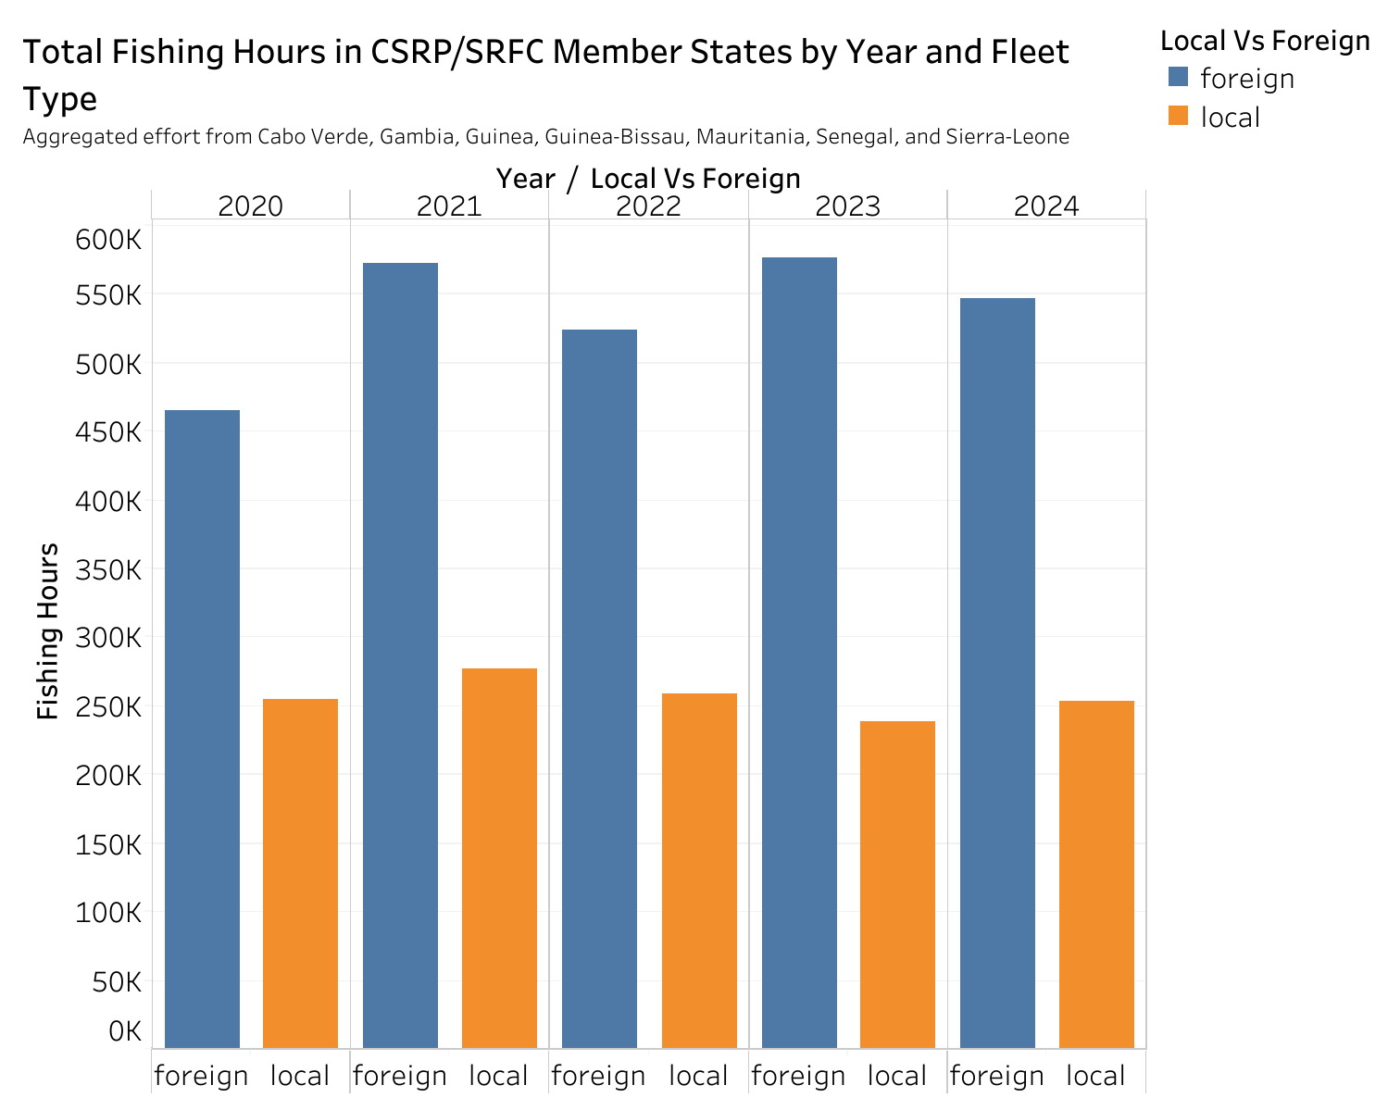

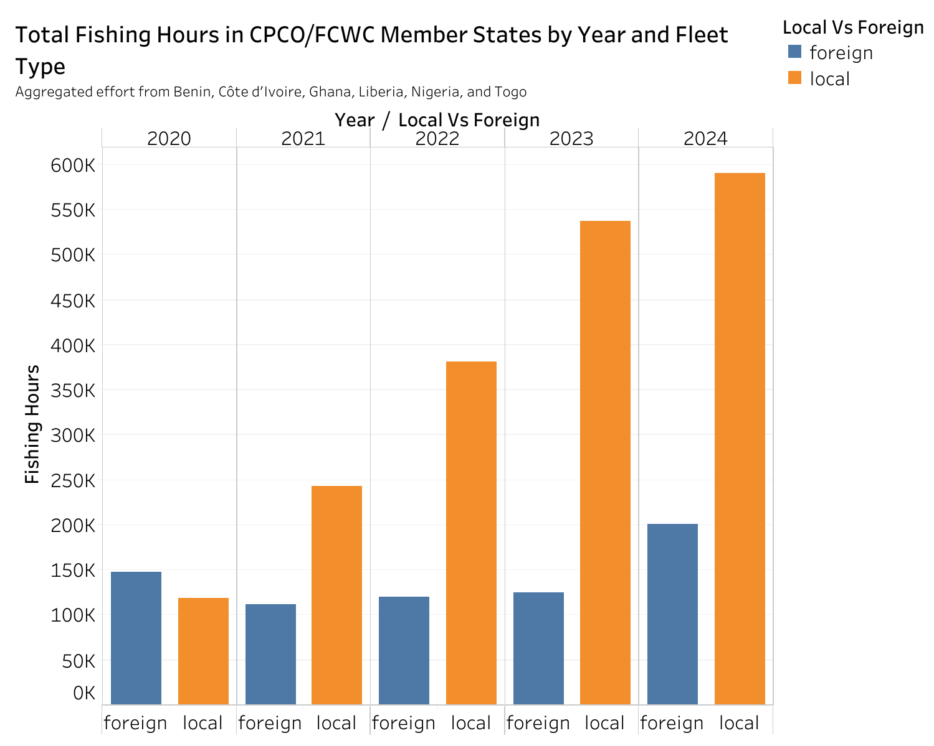

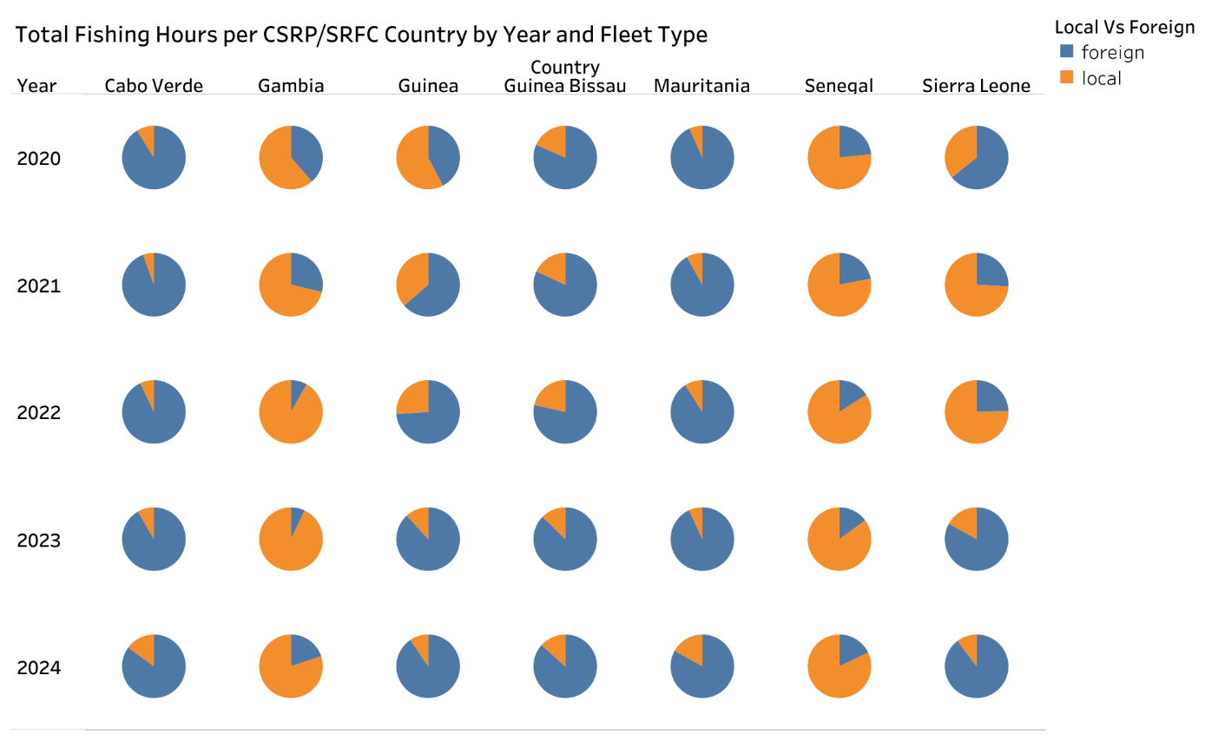

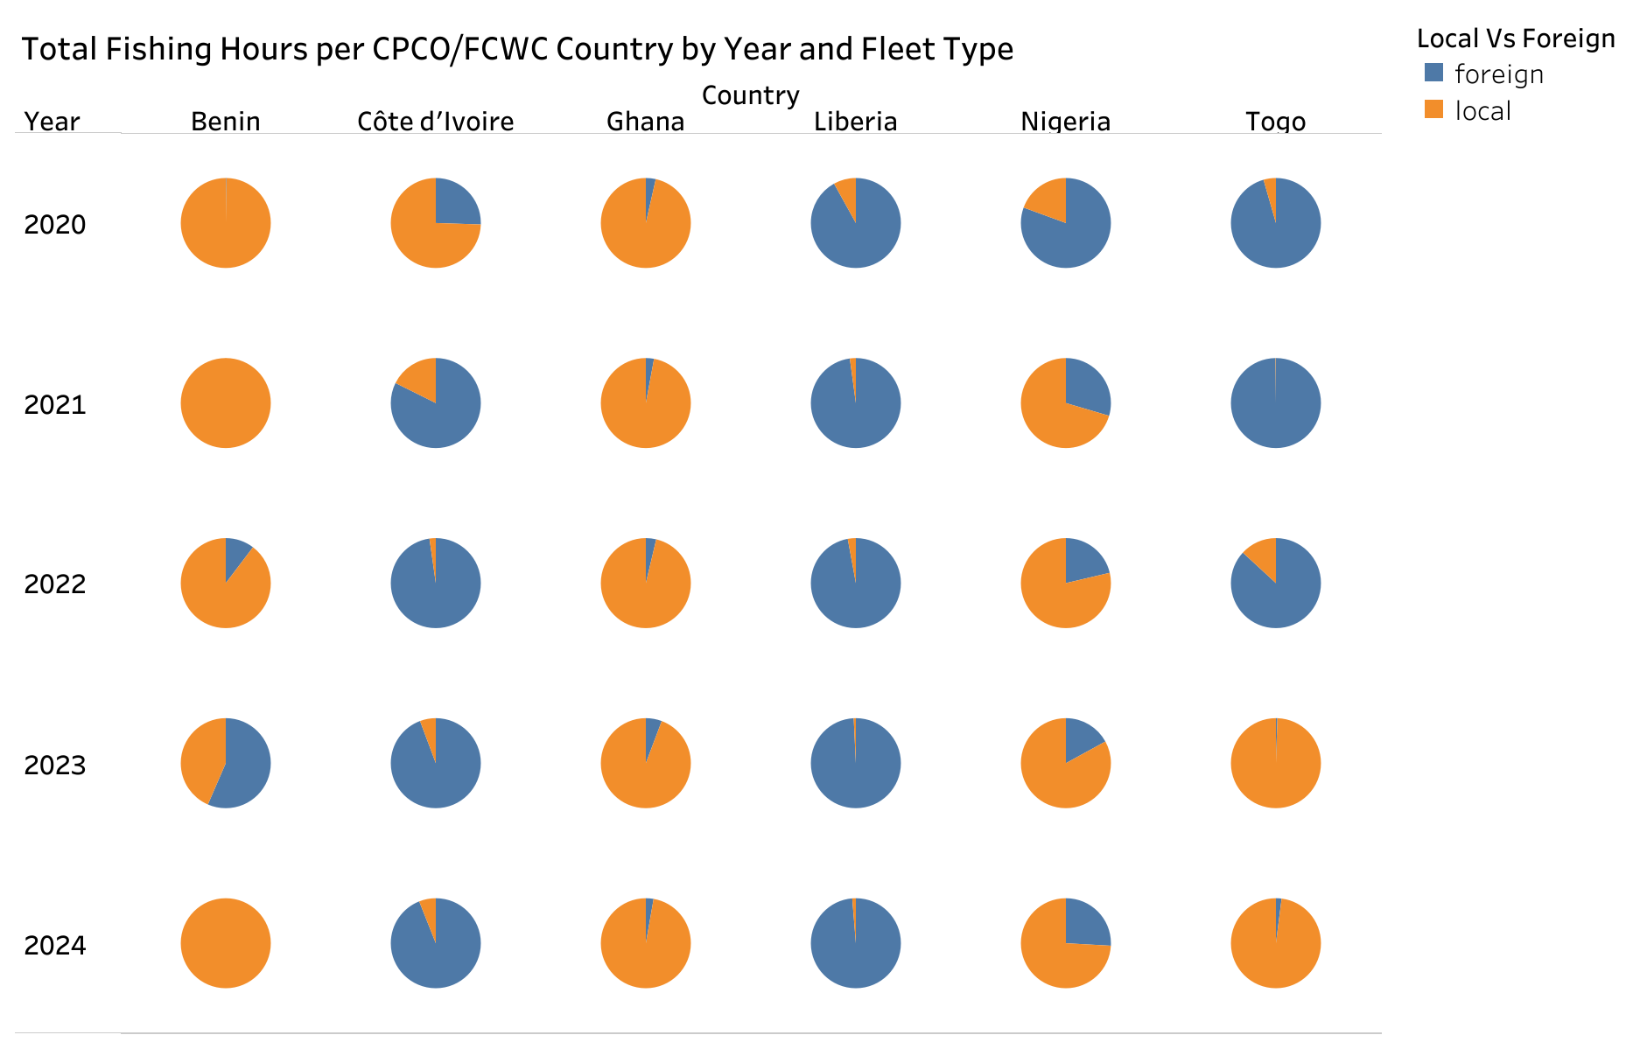

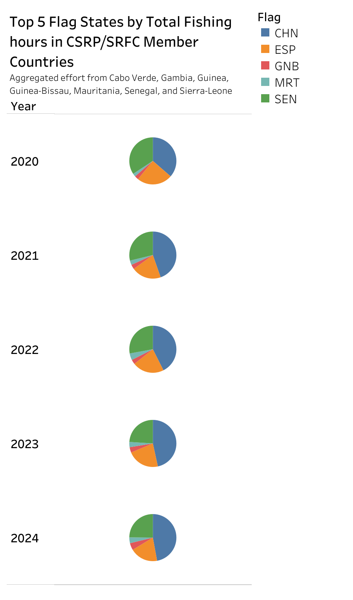

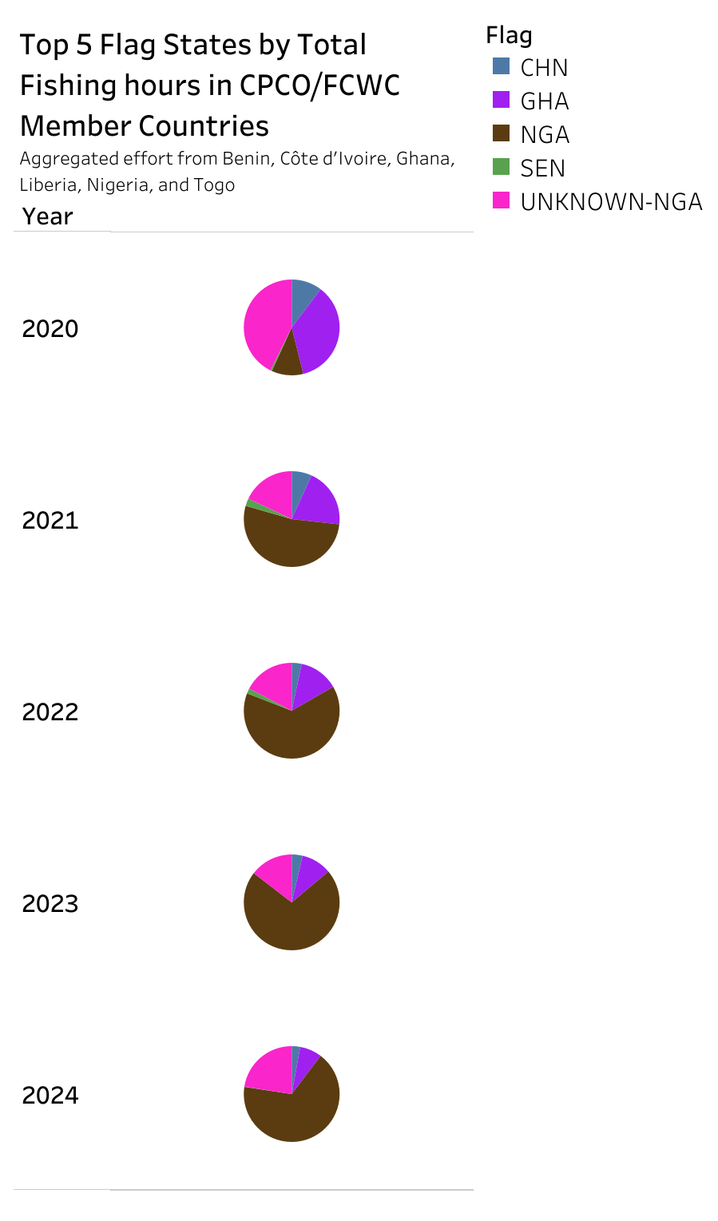

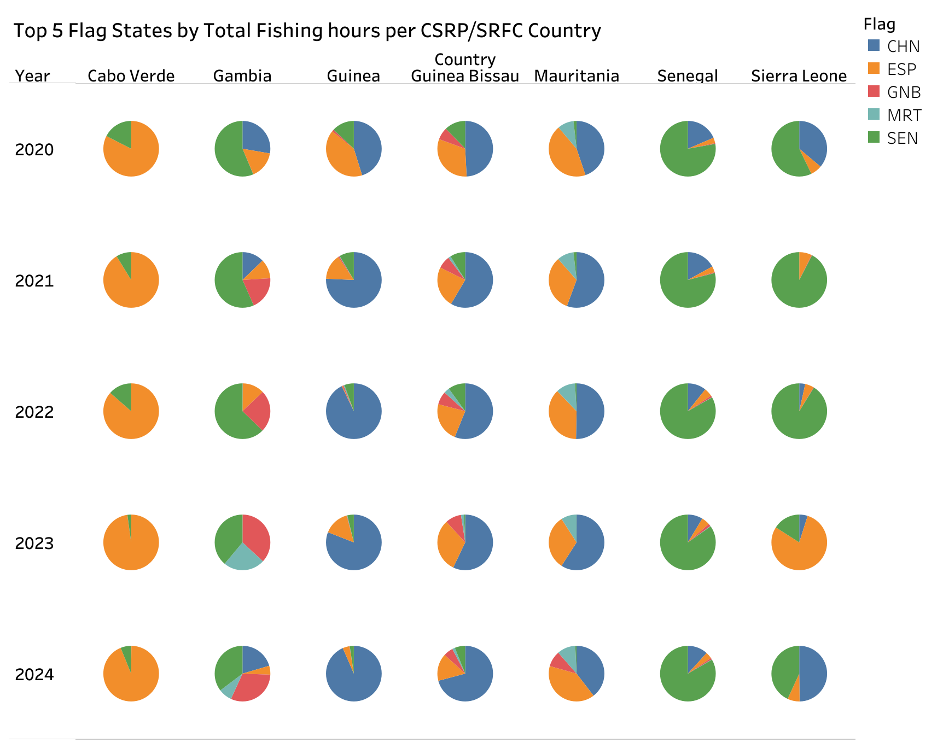

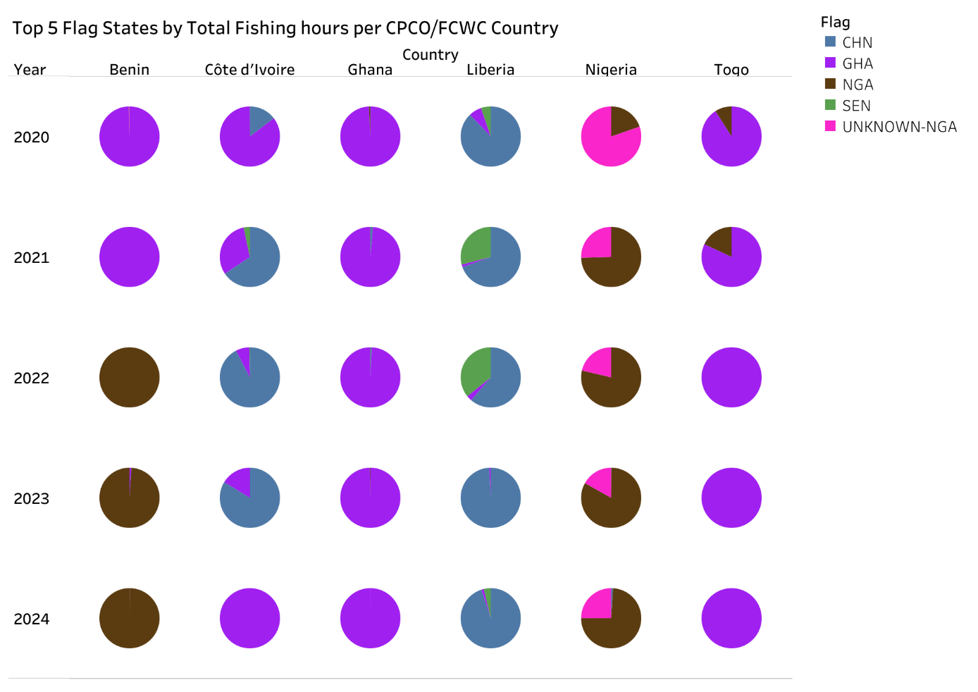

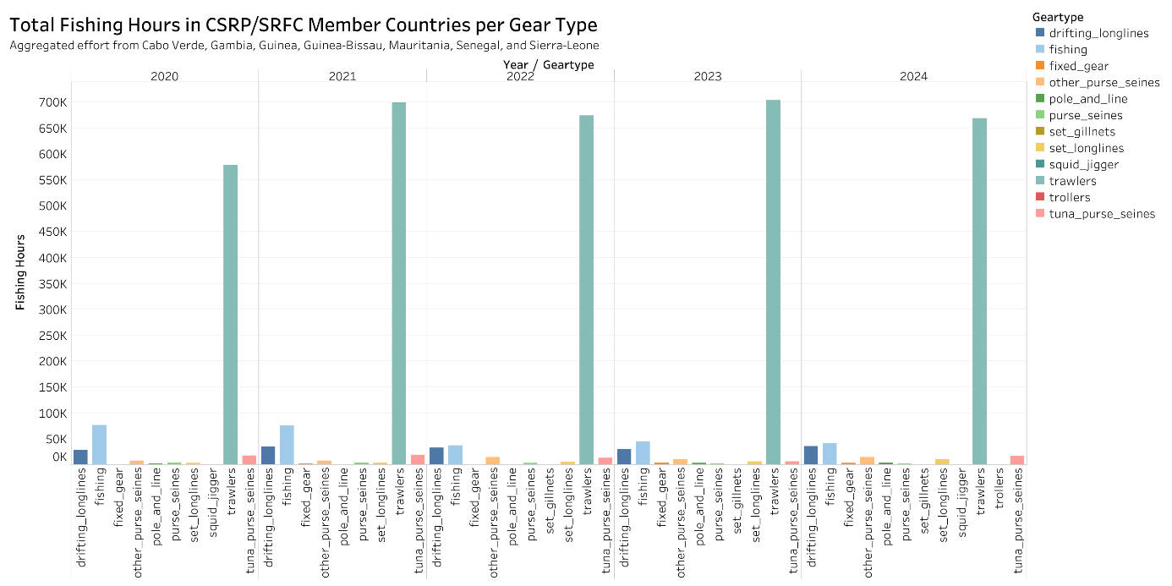

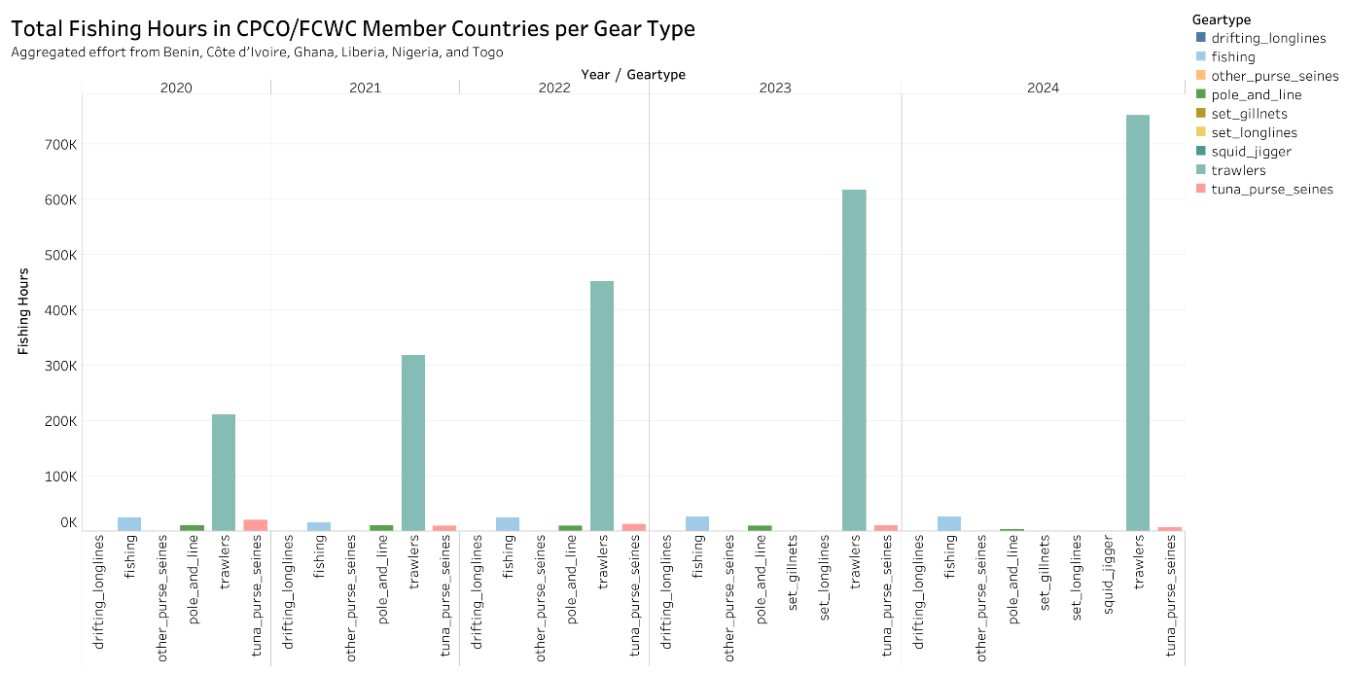

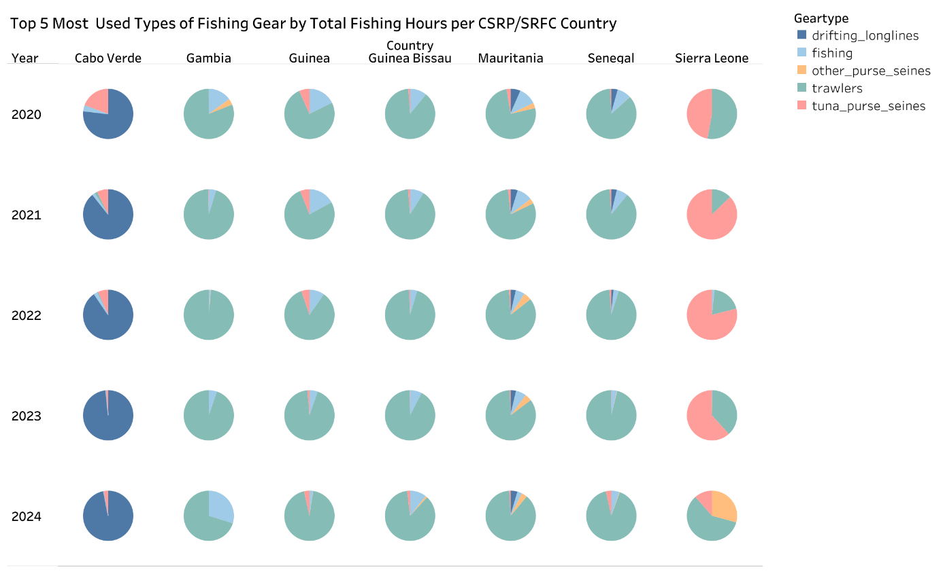

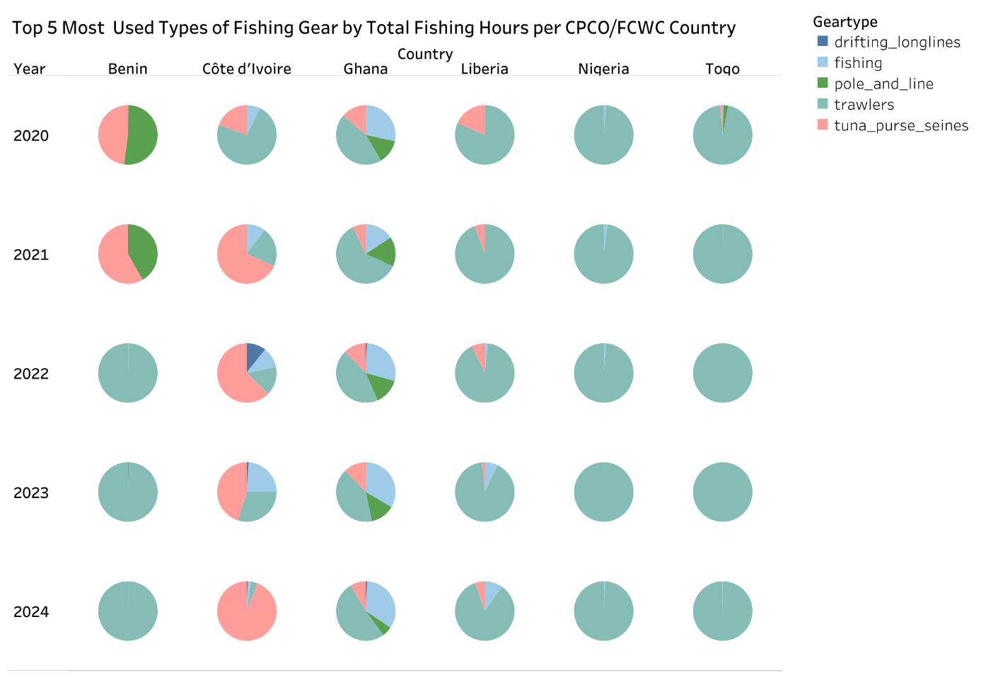

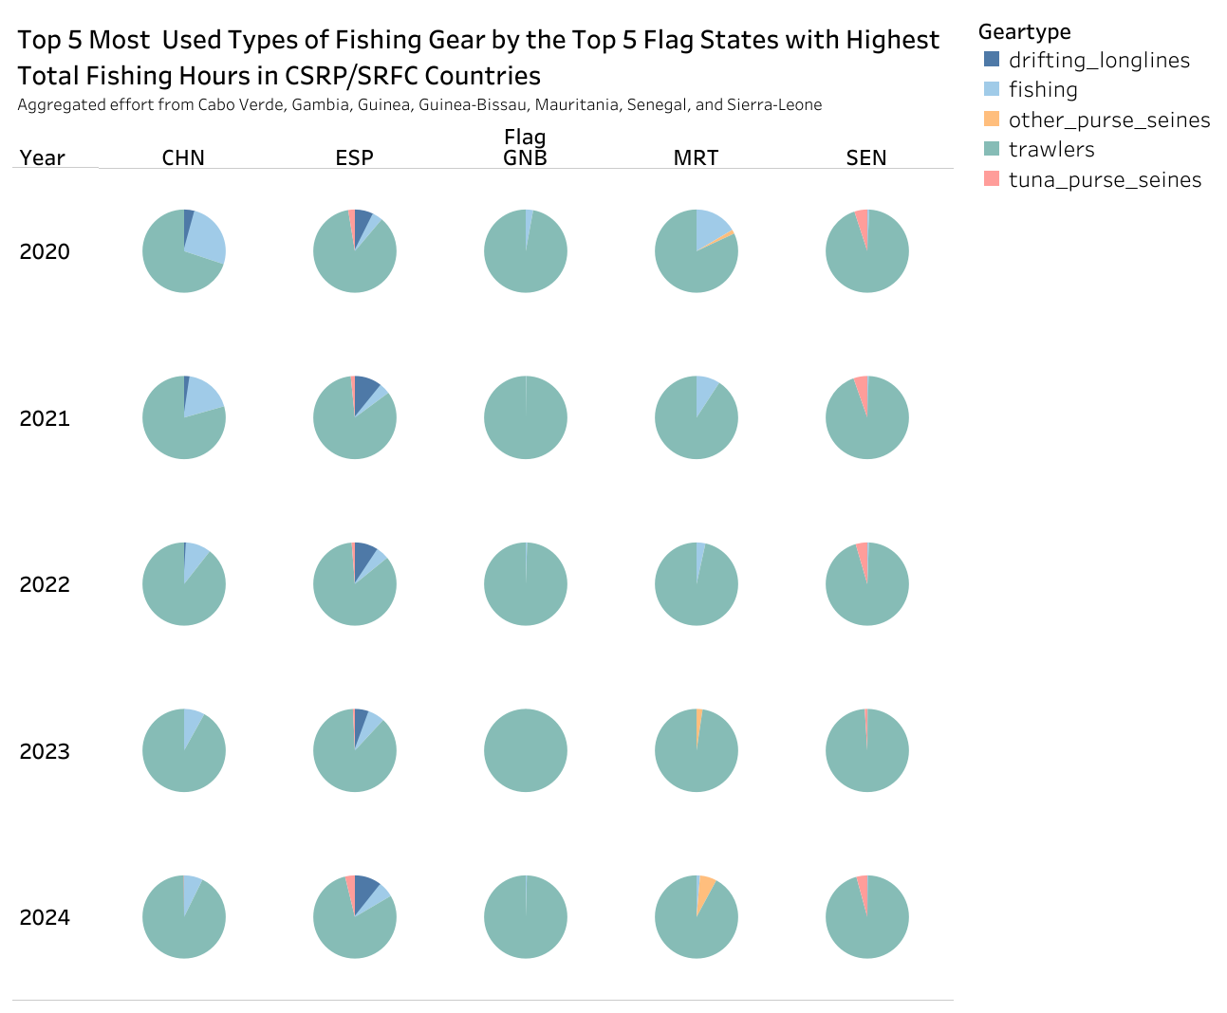

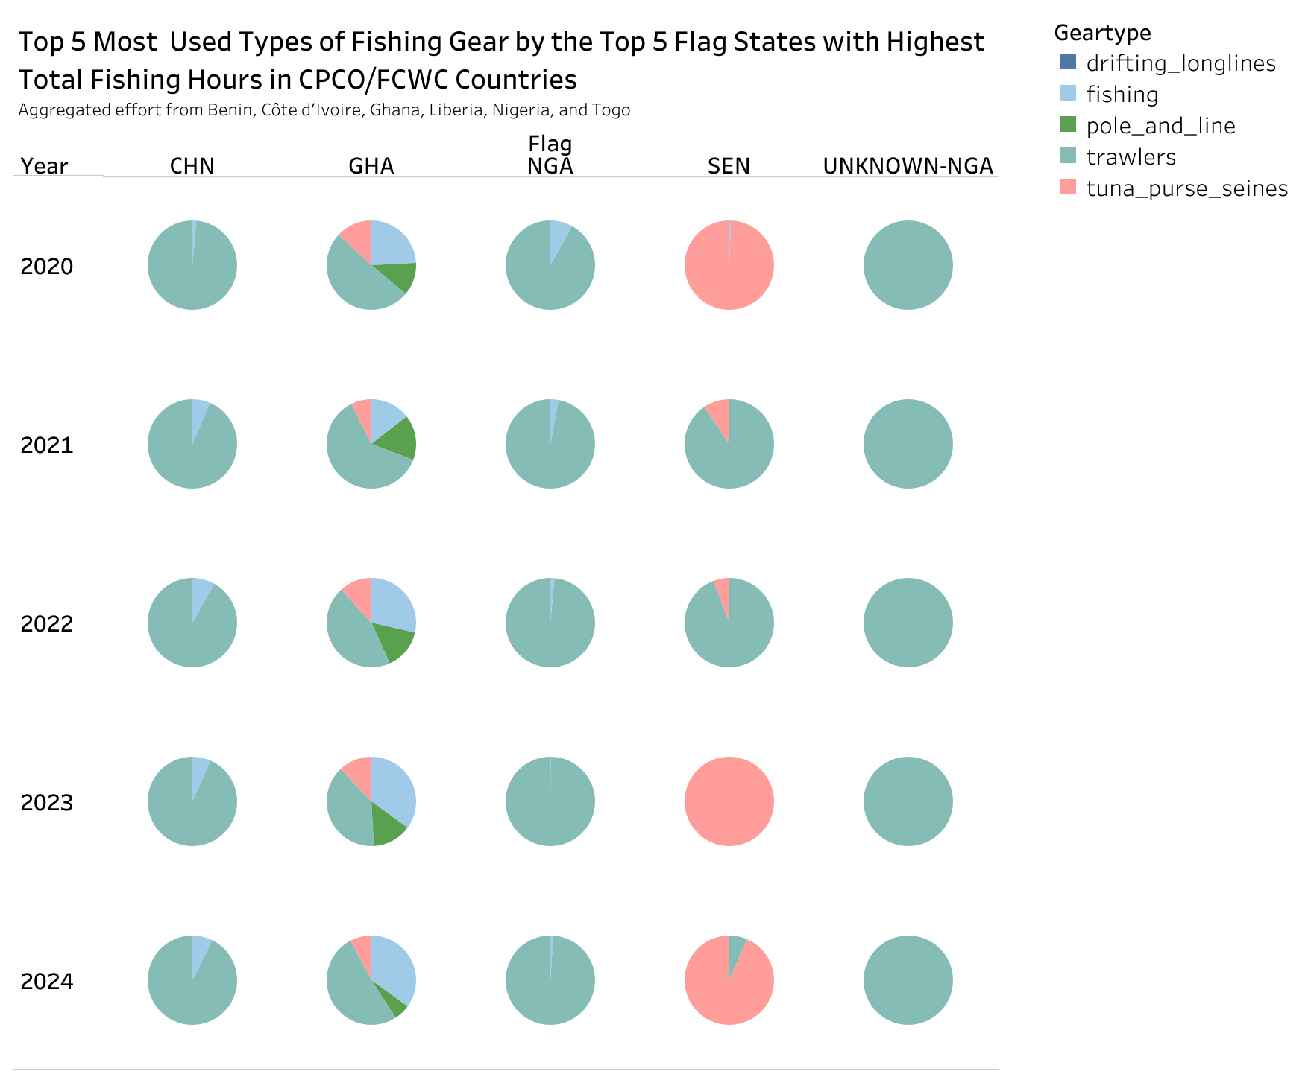

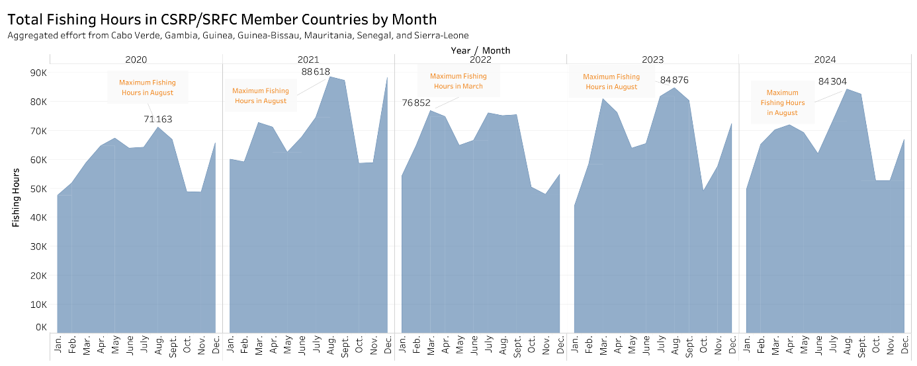

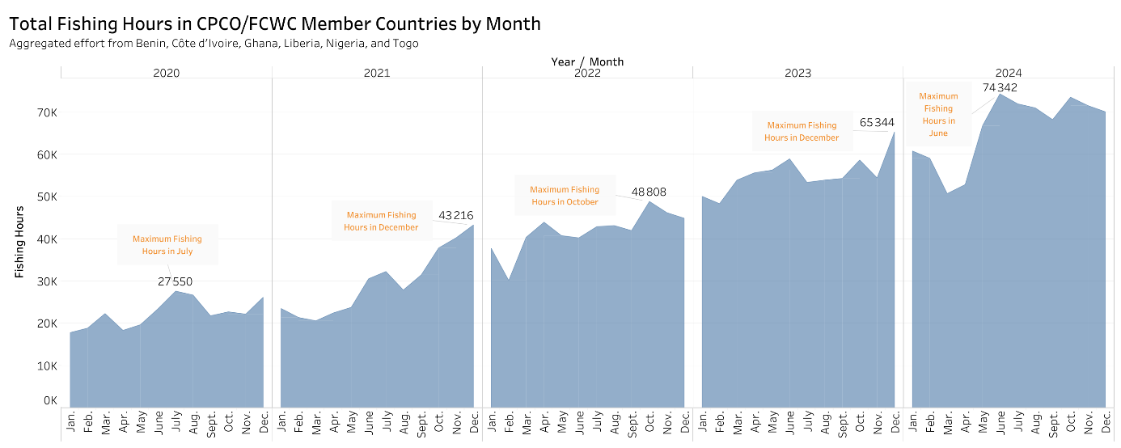

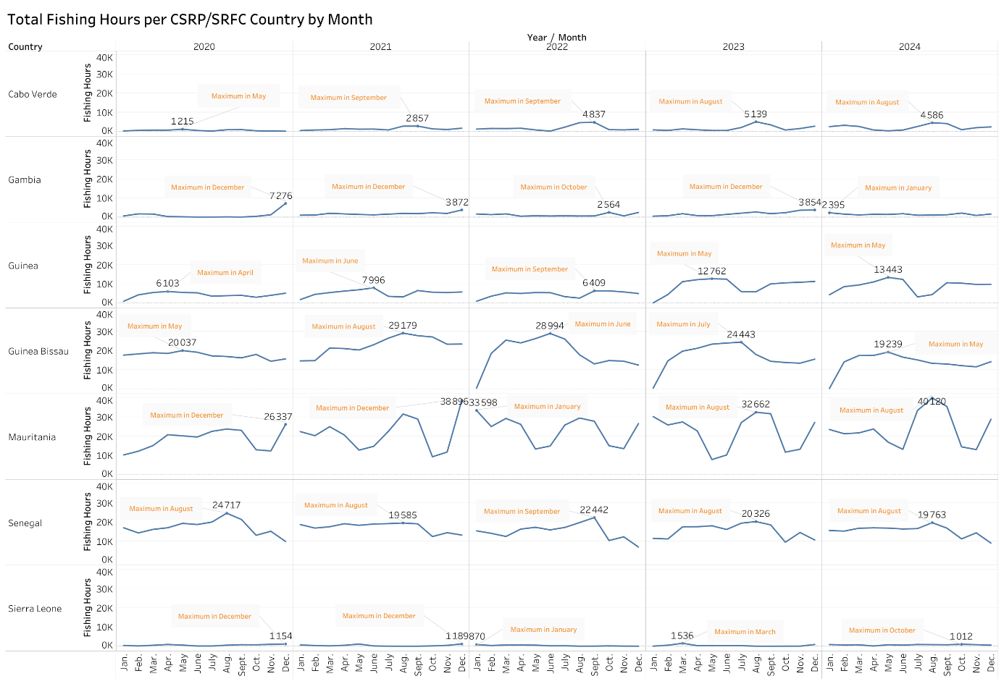

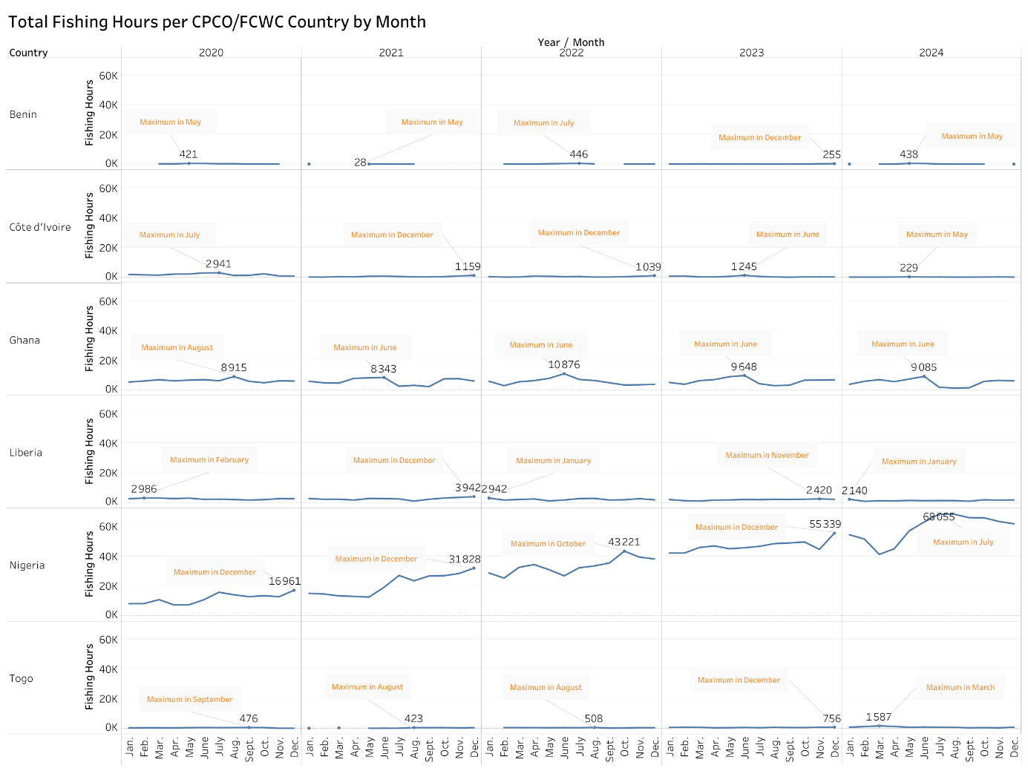

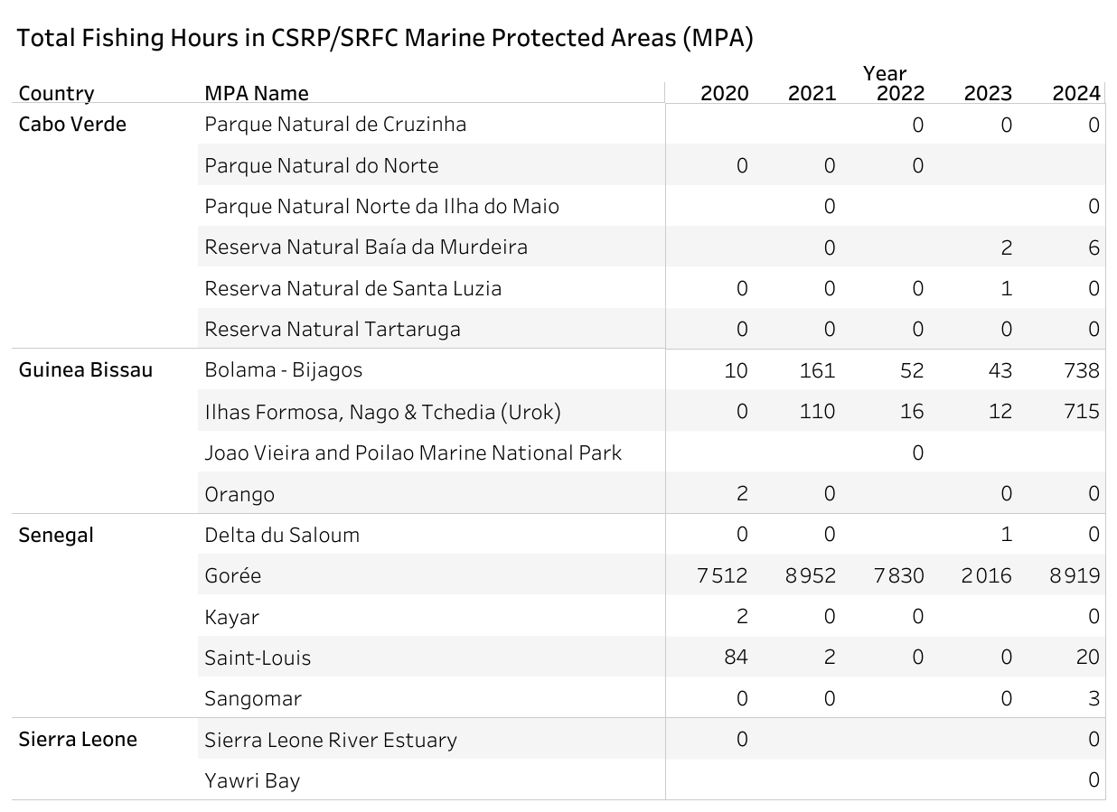

# R

**Monthly Fishing Hours with Trawlers in CSRP Member Countries**

**library**(ggplot2)

**library**(dplyr)

*# Load the data*  
fishing_data <- **read.csv2**("GFW_CSRP_Countries_2020_2024_Trawlers_Month_modified.csv")  
  
*# ✅ Ensure Fishing_Hours is numeric*  
fishing_data**$**Fishing_Hours <- **as.numeric**(fishing_data**$**Fishing_Hours)  
  
*# Prepare data*  
fishing_data <- fishing_data **%>%**  
 **mutate**(  
 Month = **factor**(Month, levels = month.name),  
 Year_Month = **interaction**(Year, Month, sep = "-")  
 ) **%>%**  
 **arrange**(Year, Month) **%>%**  
 **mutate**(Year_Month = **factor**(Year_Month, levels = **unique**(Year_Month)))  
  
*# Identify max and min month per year*  
highlight_points <- fishing_data **%>%**  
 **group_by**(Year) **%>%**  
 **mutate**(  
 is_max = Fishing_Hours **==** **max**(Fishing_Hours, na.rm = TRUE),  
 is_min = Fishing_Hours **==** **min**(Fishing_Hours, na.rm = TRUE)  
 ) **%>%**  
 **ungroup**() **%>%**  
 **mutate**(highlight_type = **case_when**(  
 is_max **~** "Max fishing hours",  
 is_min **~** "Min fishing hours",  
 TRUE **~** NA_character_  
 ))  
  
*# ✅ Ensure highlight_points$Fishing_Hours is numeric (again, just in case)*  
highlight_points**$**Fishing_Hours <- **as.numeric**(highlight_points**$**Fishing_Hours)  
  
*# Plot*  
**ggplot**() **+**  
 *# Bar layer for years*  
 **geom_bar**(  
 data = fishing_data,  
 **aes**(x = Year_Month, y = Fishing_Hours, fill = **factor**(Year)),  
 stat = "identity", color = "white", width = 1  
 ) **+**  
 *# Highlight points for max/min months*  
 **geom_point**(  
 data = **filter**(highlight_points, **!is.na**(highlight_type)),  
 **aes**(x = Year_Month, y = Fishing_Hours **+** 50, color = highlight_type),  
 size = 4, shape = 16, inherit.aes = FALSE  
 ) **+**  
 **coord_polar**(start = 0) **+**  
 **scale_x_discrete**(labels = **substr**(**rep**(month.name, times = **length**(**unique**(fishing_data**$**Year))), 1, 1)) **+**  
 **scale_fill_brewer**(palette = "Set2", name = "Year") **+**  
 **scale_color_manual**(  
 name = "Highlights",  
 values = **c**(  
 "Max fishing hours" = "red",  
 "Min fishing hours" = "green"  
 )  
 ) **+**  
 **labs**(  
 title = "Monthly Fishing Hours with Trawlers in CSRP Member Countries (2020–2024)",  
 x = "", y = ""  
 ) **+**  
 **guides**(  
 fill = **guide_legend**(order = 1),  
 color = **guide_legend**(order = 2, override.aes = **list**(shape = 16, size = 4))  
 ) **+**  
 **theme_minimal**(base_size = 14) **+**  
 **theme**(  
 axis.text.x = **element_text**(size = 10),  
 axis.text.y = **element_blank**(),  
 panel.grid = **element_blank**(),  
 axis.ticks = **element_blank**(),  
 legend.box = "vertical",  
 legend.spacing.y = **unit**(0.3, 'cm')  
 )

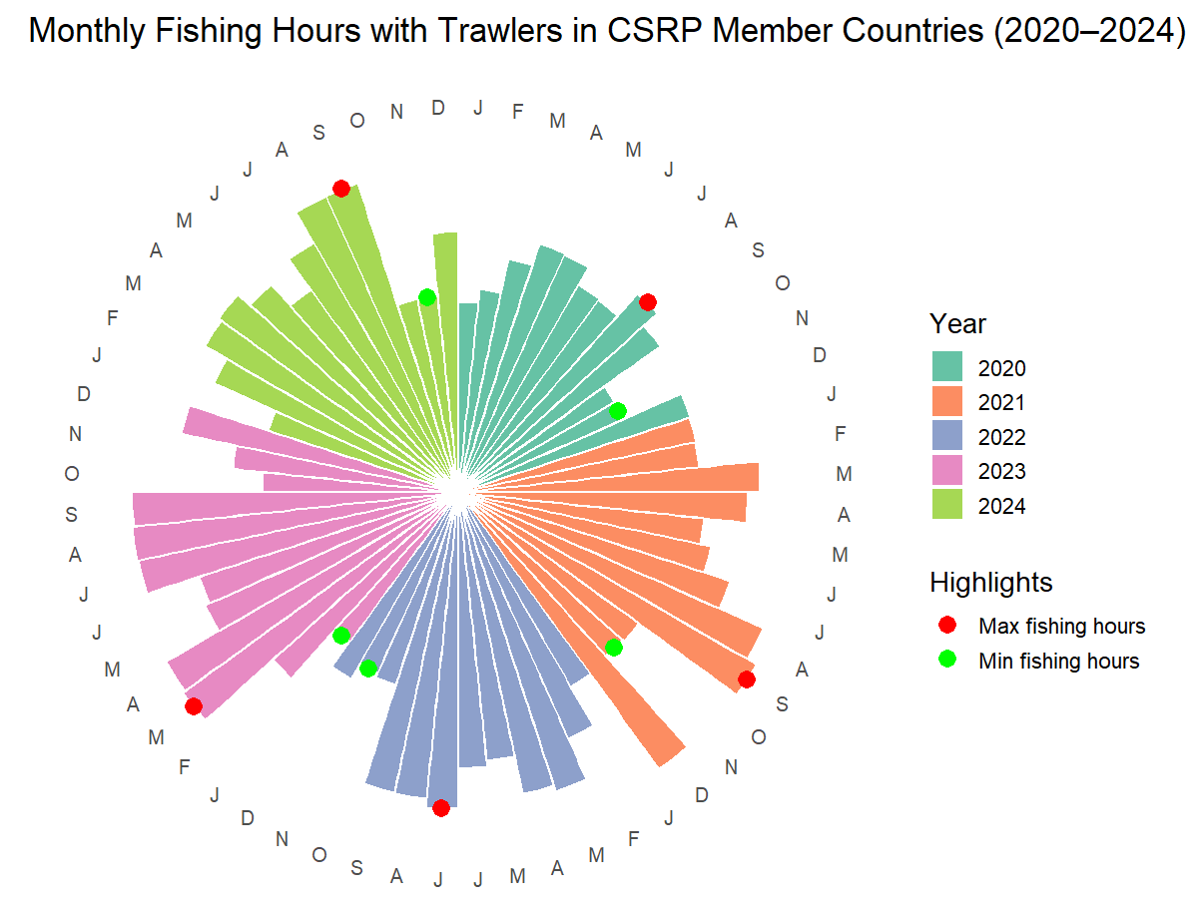

**Monthly Fishing Hours with Trawlers in CPCO Member Countries**

**library**(ggplot2)

**library**(dplyr)

*# Load the data*  
fishing_data <- **read.csv2**("GFW_CPCO_Countries_2020_2024_Trawlers_Month_modified.csv")  
  
*# ✅ Ensure Fishing_Hours is numeric*  
fishing_data**$**Fishing_Hours <- **as.numeric**(fishing_data**$**Fishing_Hours)  
  
*# Prepare data*  
fishing_data <- fishing_data **%>%**  
 **mutate**(  
 Month = **factor**(Month, levels = month.name),  
 Year_Month = **interaction**(Year, Month, sep = "-")  
 ) **%>%**  
 **arrange**(Year, Month) **%>%**  
 **mutate**(Year_Month = **factor**(Year_Month, levels = **unique**(Year_Month)))  
  
*# Identify max and min month per year*  
highlight_points <- fishing_data **%>%**  
 **group_by**(Year) **%>%**  
 **mutate**(  
 is_max = Fishing_Hours **==** **max**(Fishing_Hours, na.rm = TRUE),  
 is_min = Fishing_Hours **==** **min**(Fishing_Hours, na.rm = TRUE)  
 ) **%>%**  
 **ungroup**() **%>%**  
 **mutate**(highlight_type = **case_when**(  
 is_max **~** "Max fishing hours",  
 is_min **~** "Min fishing hours",  
 TRUE **~** NA_character_  
 ))  
  
*# ✅ Ensure highlight_points$Fishing_Hours is numeric (again, just in case)*  
highlight_points**$**Fishing_Hours <- **as.numeric**(highlight_points**$**Fishing_Hours)  
  
*# Plot*  
**ggplot**() **+**  
 *# Bar layer for years*  
 **geom_bar**(  
 data = fishing_data,  
 **aes**(x = Year_Month, y = Fishing_Hours, fill = **factor**(Year)),  
 stat = "identity", color = "white", width = 1  
 ) **+**  
 *# Highlight points for max/min months*  
 **geom_point**(  
 data = **filter**(highlight_points, **!is.na**(highlight_type)),  
 **aes**(x = Year_Month, y = Fishing_Hours **+** 50, color = highlight_type),  
 size = 4, shape = 16, inherit.aes = FALSE  
 ) **+**  
 **coord_polar**(start = 0) **+**  
 **scale_x_discrete**(labels = **substr**(**rep**(month.name, times = **length**(**unique**(fishing_data**$**Year))), 1, 1)) **+**  
 **scale_fill_brewer**(palette = "Set2", name = "Year") **+**  
 **scale_color_manual**(  
 name = "Highlights",  
 values = **c**(  
 "Max fishing hours" = "red",  
 "Min fishing hours" = "green"  
 )  
 ) **+**  
 **labs**(  
 title = "Monthly Fishing Hours with Trawlers in CPCO Member Countries (2020–2024)",  
 x = "", y = ""  
 ) **+**  
 **guides**(  
 fill = **guide_legend**(order = 1),  
 color = **guide_legend**(order = 2, override.aes = **list**(shape = 16, size = 4))  
 ) **+**  
 **theme_minimal**(base_size = 14) **+**  
 **theme**(  
 axis.text.x = **element_text**(size = 10),  
 axis.text.y = **element_blank**(),  
 panel.grid = **element_blank**(),  
 axis.ticks = **element_blank**(),  
 legend.box = "vertical",  
 legend.spacing.y = **unit**(0.3, 'cm')  
 )

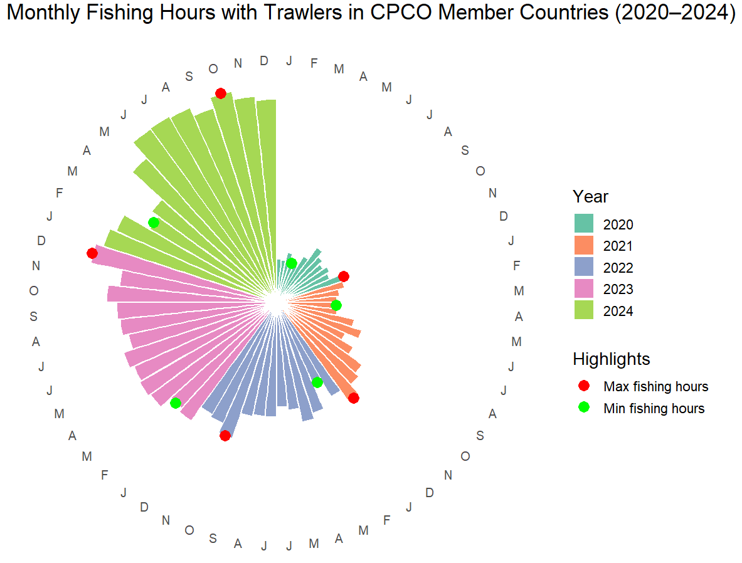

**Monthly Fishing Hours with Trawlers in CSRP per Country, Case of Senegal (The same R code was applied for the other countries and those of CPCO)**

**library**(ggplot2)

**library**(dplyr)

*# Load the data*  
fishing_data <- **read.csv2**("GFW_CSRP_Senegal_2020_2024_Trawlers_Month.csv")  
  
*# ✅ Ensure Fishing_Hours is numeric*  
fishing_data**$**Fishing_Hours <- **as.numeric**(fishing_data**$**Fishing_Hours)  
  
*# Prepare data*  
fishing_data <- fishing_data **%>%**  
 **mutate**(  
 Month = **factor**(Month, levels = month.name),  
 Year_Month = **interaction**(Year, Month, sep = "-")  
 ) **%>%**  
 **arrange**(Year, Month) **%>%**  
 **mutate**(Year_Month = **factor**(Year_Month, levels = **unique**(Year_Month)))  
  
*# Identify max and min month per year*  
highlight_points <- fishing_data **%>%**  
 **group_by**(Year) **%>%**  
 **mutate**(  
 is_max = Fishing_Hours **==** **max**(Fishing_Hours, na.rm = TRUE),  
 is_min = Fishing_Hours **==** **min**(Fishing_Hours, na.rm = TRUE)  
 ) **%>%**  
 **ungroup**() **%>%**  
 **mutate**(highlight_type = **case_when**(  
 is_max **~** "Max fishing hours",  
 is_min **~** "Min fishing hours",  
 TRUE **~** NA_character_  
 ))  
  
*# ✅ Ensure highlight_points$Fishing_Hours is numeric (again, just in case)*  
highlight_points**$**Fishing_Hours <- **as.numeric**(highlight_points**$**Fishing_Hours)  
  
*# Plot*  
**ggplot**() **+**  
 *# Bar layer for years*  
 **geom_bar**(  
 data = fishing_data,  
 **aes**(x = Year_Month, y = Fishing_Hours, fill = **factor**(Year)),  
 stat = "identity", color = "white", width = 1  
 ) **+**  
 *# Highlight points for max/min months*  
 **geom_point**(  
 data = **filter**(highlight_points, **!is.na**(highlight_type)),  
 **aes**(x = Year_Month, y = Fishing_Hours **+** 50, color = highlight_type),  
 size = 4, shape = 16, inherit.aes = FALSE  
 ) **+**  
 **coord_polar**(start = 0) **+**  
 **scale_x_discrete**(labels = **substr**(**rep**(month.name, times = **length**(**unique**(fishing_data**$**Year))), 1, 1)) **+**  
 **scale_fill_brewer**(palette = "Set2", name = "Year") **+**  
 **scale_color_manual**(  
 name = "Highlights",  
 values = **c**(  
 "Max fishing hours" = "red",  
 "Min fishing hours" = "green"  
 )  
 ) **+**  
 **labs**(  
 title = "Monthly Fishing Hours with Trawlers per CSRP Country, Case of Senegal (2020–2024)",  
 x = "", y = ""  
 ) **+**  
 **guides**(  
 fill = **guide_legend**(order = 1),  
 color = **guide_legend**(order = 2, override.aes = **list**(shape = 16, size = 4))  
 ) **+**  
 **theme_minimal**(base_size = 14) **+**  
 **theme**(  
 axis.text.x = **element_text**(size = 10),  
 axis.text.y = **element_blank**(),  
 panel.grid = **element_blank**(),  
 axis.ticks = **element_blank**(),  
 legend.box = "vertical",  
 legend.spacing.y = **unit**(0.3, 'cm')  
 )

